

Master’s Degree: Sustainable Engineering and Climate Change


A multi-criteria analysis of sustainable mobility policies in Shenzhen

Master Thesis of Eirini Boulinaki

Examination Committee:
THEOCHARIS TSOUTSOS, PROFESSOR (SUPERVISOR)
TRYFON DARAS, ASSOC. PROFESSOR
DESPOINA DIMELLI, ASSOC. PROFESSOR

Chania, January 2023
Με επιφύλαξη παντός δικαιώματος. All rights reserved. ©

Απαγορεύεται η αντιγραφή, αποθήκευση και διανομή της παρούσας εργασίας, εξ ολοκλήρου ή τμήματος αυτής, για εμπορικό σκοπό. Επιτρέπεται η ανατύπωση, αποθήκευση και διανομή για μη κερδοσκοπικό σκοπό, εκπαιδευτικού ή ερευνητικού χαρακτήρα, με την προϋπόθεση να αναφέρεται η πηγή προέλευσης. Ερωτήματα που αφορούν τη χρήση της εργασίας για άλλη χρήση θα πρέπει να απευθύνονται προς το συγγραφέα. Οι απόψεις και τα συμπεράσματα που περιέχονται σε αυτό το έγγραφο εκφράζουν τον συγγραφέα και δεν πρέπει να ερμηνευθεί ότι αντιπροσωπεύουν τις επίσημες θέσεις του Πολυτεχνείου Κρήτης.

Abstract
With transportation to have such a huge impact on one’s everyday life and on the environment, it is of crucial importance for sustainable mobility policies to be set on place.
On this study different sustainable mobility policies were ranked by using multi-criteria analysis (MCDA). The city that the research was done on is the city of Shenzhen, China, which was one of the first Special Economic Zone set by the Chinese government for the 6th 5-year Plan of the People’s Republic of China. Six stakeholder groups (Local Authorities, Mobility Experts, Academics, Environmental groups and Local Communities) were asked to rank 10 criteria that belonged in 5 groups (Environment, Economy, Special Economic Zone Growth, Local Communities, Mobility) and PROMETHEE tool was used to rank 11 different sustainable mobility policies based on the answers and literature review. The results were to be compared with relevant research done in a Mediterranean city.
The investigated mobility measures were divided in 5 main categories, covering the environment, mobility, foreign supported special economic zone growth, economy and local communities. The 10 chosen criteria derived from the 5 categories were involved the energy, environmental pollution, the traffic conditions, the transport infrastructure, the foreigners’ experience, the service finance, the local economy, the safety and the accessibility. Among the investigated actions were included the strategic plans for urban mobility and logistics, the real time monitoring system, actions for increasing safety and security, the mobility plans for schools communities’, the attractive and accessible public spaces, the shared mobility services, the e-charging infrastructure, the mobility management plans, the behavioral change and informative actions, the low emission zones and parking management, and the improved and accessible public transport services.
According to PROMETHEE results, Mobility management and travel plans was the optimal policy for the city of Shenzhen, which happens to be the same for the Mediterranean city. In general, both the Chinese and the European participants prioritized the reduction of the environmental pollution, although the stakeholder groups seem to have different opinions on what is least important for their communities.

Περίληψη
Οι μεταφορές έχουν ένα μεγάλο αντίκτυπο στην καθημερινότητα των πολιτών και στο περιβάλλον γι’αυτό το λόγο είναι υψίστης σημασίας να εφαρμοστούν βιώσιμες πολιτικές για την κινητικότητα.
Σε αυτή τη μελέτη διάφορες βιώσιμες πολιτικές κινητικότητας κατατάχθηκαν κατά σειρά προτίμησης χρησιμοποιόντας πολυ-κριτιριακή μέθοδο. Η πόλη για την οποία έγινε η έρευνα είναι η κινεζική πόλη του Σενζέν, η οποία ήταν μία από τις πρώτες Ζώνες Ειδικής Οικονομίας οι οποίες ορίστηκαν από την κινεζική κυβέρνηση για το 6^{ο} πενταετές πλάνο της Κινεζικής Δημοκρατίας της Κίνας. Έξι ενδιαφερόμενες ομάδες κατέταξαν δεκα κριτήρια (τα οποία άνηκαν σε πέντε κατηγορίες) και η μέθοδος πολυκριτηριακής ανάλυσης PROMETHEE ΙΙ χρησιμοποιήθηκε για να τοποθετηθούν σε σειρά προτεραιότητας έντεκα βιώσιμες πολιτικές και μέτρα κινητικότητας βάσει των απαντήσεων που συλλέχθηκαν για τις προτεινόμενες λύσεις κινητικότητας, σε συνδυασμό με δεδομένα απο τη σχετική βιβλιογραφία για τον προσδιορισμό κρισιμων παραμέτρων οπως τα βάρη. Τα αποτελέσματα συγκρίθηκαν με τα αντίστοιχα από τον ελληνικό χώρο.
Οι πολιτικές που εξετάστηκαν χωρίστηκαν σε 5 κατηγορίες, το περιβάλλον, τη κινητικότητα, την υποστήριξη Περιοχών Ειδικής Οικονομικής πολιτικής από ξένα κεφάλαια, οικονομία και τοπικές κοινότητες. Τα 10 επιλεγμένα κριτήρια που προήλθαν από αυτές τις κατηγορίες συμπεριλαμβάνουν την ενέργεια, τη ρύπανση, κίνηση, υποδομές, εμπειρία επισκεπτών, τοπική οικονομία, ασφάλεια και προσβασιμότητα. Στις πολιτικές που εξετάσθηκαν συμπεριλαμβάνονται τα στρατηγικά μέτρα για αστική κινητικότητα, τα συστήματα παρακολούιησης σε πραγματικό χρόνο, μέτρα για αυξηση ασφάλειας, μέτρα για δημιουργία πιο ελκιστηκών δημοσίων χώρων, υποδομές φόρτισης ηλεκτροκίνητων οχημάτων καθώς και δράσεις για την αλλαγή στην οδική συμπεριφορά, διαχείρηση στάθμευσης, περιοχές χαμηλών εκπομπών και βελτίωση προσβασιμότητας στα μέσα μαζικής μεταφοράς.
Σύμφωνα με τα αποτελέσματα του PROMETHEE, η τα συστήματα διαχείρισης κινητικότητας και τα ολοκληρωμένα σχέδια μετακίνησης για ομάδες του πληθυσμού οργανωμένα από φορείς, ήταν η καταλληλότερη πολιτική και για τις δύο πόλεις. Γενικά, τόσο οι Κινέζοι όσο και οι Ευρωπαίοι συμμετέχοντες έχουν ως προτεραιότητα τη μείωση της περιβαλοντικής ρύπανσης, αν και οι ενδιαφερόμενες ομάδες φάνηκαν να διαφωνούν για την κατάταξη των μέτρων με χαμηλότερη σπουδαιότητα εντός του χώρου ενδιαφέροντος.
Contents
1. Introduction 10
1.1. The importance of transportation 10
1.2. Scope and objectives of the study 10
2. State of the art 14
2.1. Policies and measures towards sustainable mobility 14
2.2. The Multi-Criteria Analysis Method in transportation 16
2.3. Sustainable mobility and COVID-19 ………………………………………..……………17
3. Methodology………………………………………………………………..……………..20
3.1. PROMETHEE Tool………………………………………………………………………...20
3.2. Terms used 21
3.3. Steps Followed 37
4. Results 38
5. Discussion and Conclusions 47
5.1. Policies ranking…...………………………………………………………………………. 47
5.2. Weights........……….……………………………………………………………………….49
5.3. Challenges ….........………………………………………………………………………...52
6. Ideas for Future Research 55
7. References…………………………………………………………………………………57

Acknowledgements

I would like to express my deepest gratitude to my supervisors, Dr. Theocharis Tsoutsos and Maria Aryblia. They have both been a great support throughout this academic endeavor and they never seemed to lose hope in my ability to cope with it. In moments that I felt like giving up, they were both there to show me the bigger picture, motivate me and then set higher and more fulfilling expectations.

For all you have done, allow me to express my appreciation.

List of Figures
Figure 1.1 – Electric Bus in from Shenzhen Bus, Zhou Guangi, 2018 11
Figure 1.2 -Micro Mobility………………………………………………………………………..12
Figure 2.1- Light pollution in China………………………………………………...…………….17
Figure 2.2 – Quarantine building, Beijing, August 2021 19
Figure 3.1 – The evaluation table 21
Figure 3.2 – The SUMP process 22
Figure 3.3 - The Chinese PROMETHEE questionnaire………………………………………….27
Figure 3.4 – Description of evaluation criteria in Chinese 28
Figure 3.5 Response collected through BISZ Library……………………………………………31
Figure 3.6 – Response collected through Expat Women in SZ……………..……………………..32
Figure 3.7 - Relative weights calculations for Mobility Experts group 33
Figure 3.8 – Relative waves calculations for Mobility Experts group 33
Figure 3.9 - Relative waves calculations for Mobility Experts group 34
Figure 3.10 - Evaluation of Actions based on the different Criteria 35
Figure 3.11 - Ranking Description 36
Figure 4.1 - Evaluation matrix 39
Figure 4.2 - Weights for PT Operators 40
Figure 4.3 - PROMETHEE Flow Table for PT Operators 40
Figure 4.4 - Weights for Local Authorities 41
Figure 4.5- PROMETHEE Flow Table for Local Authorities 41
Figure 4.6 - Weights for Academic Institutions 42
Figure 4.7 - PROMETHEE Flow Table for Academic Institutions 42
Figure 4.8 - Weights for Mobility Experts 43
Figure 4.9 - PROMETHEE Flow Table for Mobility Experts 43
Figure 4.10 - Weights for Environmental Groups 44
Figure 4.11 - PROMETHEE Flow Table for Environmental Groups 44
Figure 4.12 - Weights for Local Communities 45
Figure 4.13 - PROMETHEE Flow Table for Local Communities 45
Figure 4.14 - PROMETHEE Complete Flow Table 46
Figure 5.1 - Scenario comparison PROMETHEE II 47
Figure 5.2 - Scenario comparison PROMETHEE II ranking for EU Stakeholder groups 48
Figure 5.3 - Scenario comparison PROMETHEE II ranking for GR Stakeholder groups 48
Figure 5.4 - PROMETHEE II Ranking 49
Figure 5.5 - Priority and least important criteria for EU and GR stakeholder groups. 50
Figure 5.6 - Walking weight for comparison charts 51
Figure 5.7 - Walking Weights for 10% weight per criterion 52
Figure 5.8 - Daily sticker, proof of daily testing ……………………………………………….53
Figure 5.9 - Alternative transportation in SZ ………………………………………………….…54
Figure 6.1 - View of the city of SZ………………………………………………………... 56
List of tables

Table 3.1 - Description of evaluation criteria 24
Table 3.2 - Criteria Evaluation Form 26
Table 3.3 - Criteria Evaluation Form……………………………………………………………..29
Table 3.4 - Response collected through Greek Consulate of Guangdong…………………………30
Table 4.1 - Relative Criteria Weights for each stakeholders group. 38
Table 5.1 - Priorities and least important criteria (Shenzhen) 50

Abbreviations:
- GHG: Green House Gases
- US: United States
- EU: European Union
- SEZ: Special Economic Zone
- MCDA: Multi-Criteria Decision Analysis
- PROMETHEE: Preference Ranking Organization Method for Enrichment Evaluations
- GAIA: Geometrical Analysis for Interactive Aid
- AI: Artificial Intelligence
- PV: Photovoltaics
- RES: Renewable Energy Systems

Introduction

The importance of transportation
Transportation in urban environment has been a heated topic of discussion amongst different community groups since the early nineties. Aiming to understand its importance, is considered essential to define the ways that transportation impacts the daily life of humans. Access to goods and activities as crucial as education, work and health care facilities occurs by driving there while a visit to a grocery store or a pharmacy, with products and technologies from all around the world would be impossible without an extensive network of container movements though land and sea. Other than making life easier, transportation when unregulated can be harmful to communities or individuals such as traffic accidents, deforestation to improve infrastructure, GHG emissions and cargo ship oil accidents such as leaks.
An easy-to-compare process to describe the effect of transportation to the global environmental issues is the GHG emissions calculation. With transportation to be responsible for 28.4% of global emissions [1] and according to the US Environmental protection agency, although transportation is not the sector responsible for the highest GHG emission, is the one that recorded the largest absolute increase in numbers from 1990 to 2020[2]. Therefore, transportation is not only adding to the global warming issue, but also it seems to be increasing its contributions. The provision of efficient, safe and environmentally friendly transport is in the spotlight of EU’s strategic plan. European Commission adopted a set of proposals to increase efficiency in transportation and make more sustainable travel, aiming to achieve the goal of being the EU the first climate-neutral continent by 2050, since transport emissions represent around 25% of total EU’s GHGs. To achieve this, the European Green Deal seeks to manage more effectively the transport system which is critical for businesses, global supply chains and the daily lifetime of all Europeans. [3]

Scope and objectives of the study
In order to compare the impact of traveling for tourism and that of business travelling, the idea of comparing the results of said research done for touristic city of Rethymnon to the SEZ (Special Economic Zone) city of Shenzhen was formed. Shenzhen, a Chinese city of South East Asia, is a very interesting case as it was in the first group of cities that the Chinese Government made to SEZ [4]. In a SEZ the major priority is for foreign investments and companies to have a connection point to the –up until then- closed and completely self-sustained Chinese economy. That targeted financial relationship with the West and the then-British-Colony of Hong Kong was to lead to extensive exporting and an –at times debatable- increase in efficiency and total production from Chinese factories [5]. The city of Shenzhen with a population of 17.56 million in the census of 2020, used to be a small fishing village with approximately 50,000 people in 1979, the year that was turned into SEZ [6]. The rapid financial bloom and the arrival of the workers and investors created a need for suitable infrastructure not only for accommodation but also for transportation. That, in combination with the massive funding from the government made Shenzhen the city with the world’s biggest electric taxis and buses fleet [7].
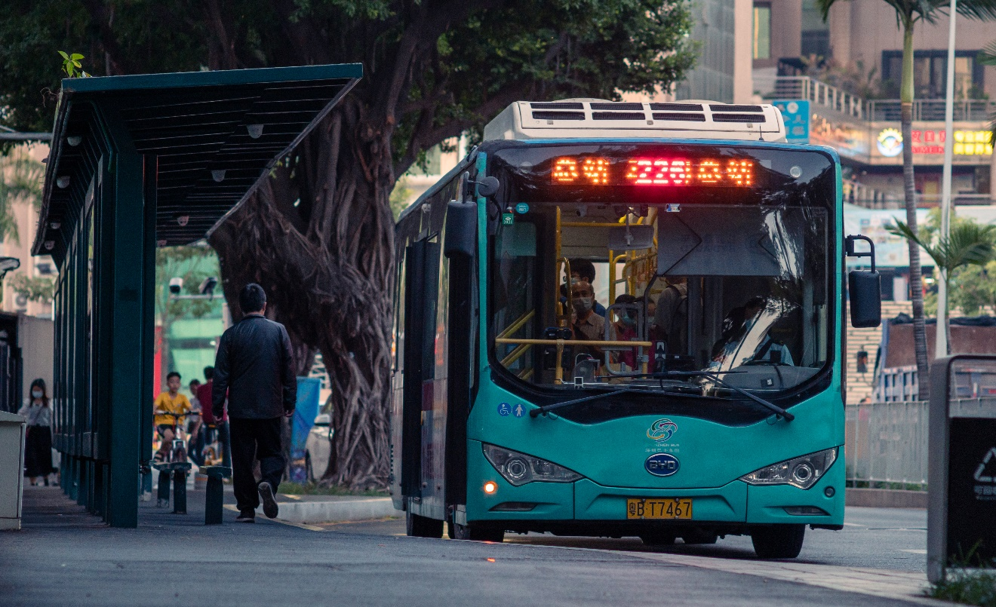
Figure 1.1 – Electric Bus in from Shenzhen Bus, Zhou Guangi, 2018
This study aims to rank the mobility policies of Shenzhen based on the views of the same 6 stakeholders’ groups (Scenarios) that were used in Farmaki’s study [8], aiming to compare the results of city of Shenzhen with those from a touristic-city, for investigating the replicability and efficiency of a mobility measure, applicable to an extended range of cities with different characteristics. In this study, the special characteristics of a city i.e. tourism or special economic zone, are in the frontline.
Using the multi-criteria analysis method of PROMETHEE II, the ranking involved 6 main target groups: Transport Operators, Local Authorities, Academic Institutions, Mobility Experts, Environmental groups and Local communities. The representatives of those different groups were invited to rank the following 10 criteria from most important to least important: Energy, Environmental pollution, Traffic conditions, Transport infrastructure, Experience for foreigners, Service finance, Local economy, Safety, Users satisfaction, Accessibility and those criteria acted as weigh factor to 11 different policies based on bibliography. The policies examined were the following:
- Sustainable urban mobility plans / sustainable urban logistic plans
- Smart metering/monitoring systems / real-time information
- Increased traffic safety and security - eco driving training
- Mobility plans for school communities
- Attractive and accessible public spaces
- Shared mobility services (car, taxi, micro mobility vehicles)
- E-Charging infrastructures and e-vehicles in public fleets / Update infrastructures with green energy systems (Photovoltaic Systems/equipment, Renewable Energy Sources)
- Mobility management practices
- Behavioral change and informative actions
- Low emissions zones / smart parking for cars and micro-mobility vehicles, online parking management
- Improved and accessible PT services for visitors and residents
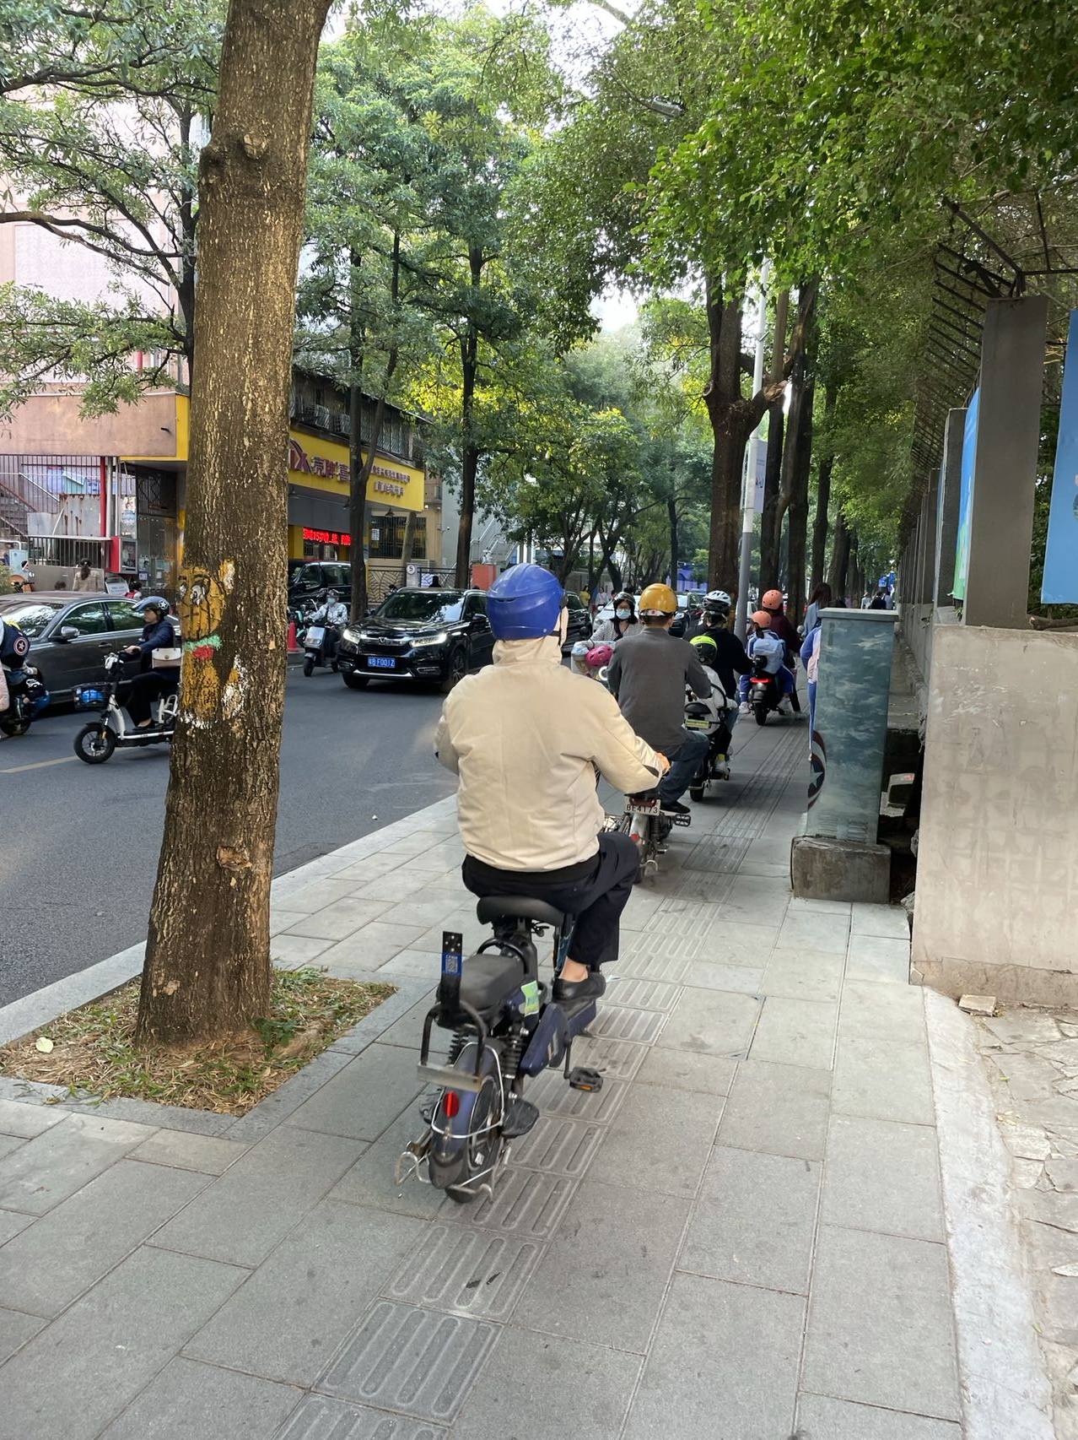
Figure 1.2 – Micro Mobility in Shenzhen, Motorcycles and bicycles are only allowed on pavements
Critical challenge to overcome was the involvement of stakeholders from all the groups of interest, since in the Chinese territory, the engagement of stakeholders for providing their perspectives and views base on their preferences is considered undoubtedly challenging. Despite the challenges, results from all the target groups were obtained.
The Multi-Criteria analysis was carried out using the Visual PROMETHEE Tool, a free online software. As a multi-criteria decision analysis tool, not only does it rank the different policies for each stakeholder group, but also gives a visual ranking of all the groups. Based on the results collected by different groups in this Chinese Mega-City, a comparison with a Mediterranean Mid-Size City can give interesting results.
The objective of this study is to promote and advocate for the sustainable transportation alternatives for the environment alongside with the local economies. Detailed explanation of the method can be found below:
- State of the art: In this chapter, relevant research and different approaches are presented.
- Design and Methodology: Detailed description of the collection of data, tool used and the mathematical approach of the weighing can be found in this chapter
- Findings: In this chapter, the outcome from PROMETHEE I and II is found and it is presented through diagrams and tables.
- Discussion and conclusions: In the final chapter, the results are commented on.
- Ideas for future research: the limitations alongside with recommendations for future research are presented.

State of the art

Policies and measures towards sustainable mobility
In order to reduce the negative aspects of transportation, governments or unions tend to enforce different policies to keep the population safe. Those policies can be as logistical and authority-lead as Sustainable Urban Mobility Plans, or as individualized as eco-driving trainings. Large scale policies like SUMP are aiming to a universal shift, not only to transportation media but also in a more sustainable type of living [9].
Depending on who is initiating the policy, it can be focused on the social or the environmental or the financial aspect of transportation, which can make the decision process very complicated. Local environmental groups would tend to have different priorities in comparison to the hospitality industry of an area for example. A way that all the different approaches can be taken into consideration is by using multi-criteria analysis. As part of the Horizon 2020 CIVITAS Destinations project multi-criteria were used to define how a set of 11 different mobility policies of a mid-sized touristic city were to be ranked, based on 10 different criteria, prioritized by 6 different stakeholders’ groups [10].
The current trend when planning for transportation nowadays has been characterized as citizen-oriented. The development of livable cities has been in the frontline since the previous decade. The mobility measures that have been investigated under the umbrella of sustainable mobility approach and the urban mobility plans have several characteristics according to their nature and can be categorized by the transport mode (car, cycling, walking, buses, etc), or according to the infrastructure specifications (mobility infrastructures – roads, pavements, bike lanes, parking slots, etc., soft policy measures, intelligent systems for monitoring and transportation).
According to the EU legislation and the corresponding mobility policies, 6 main categories have been identified, including measures, solutions and interventions that aim to encourage and facilitate the establishment of sustainable mobility in the cities.
- Urban Mobility. This category focuses on measures about traffic loads management, parking and access regulatory framework, management of demand and public transport.
- Walking and Cycling. This category includes the active mobility modes (walking and cycling), incorporating the improved infrastructure for pedestrians and cyclists, creation of public spaces and increase of free spaces for all, also efficient means to improve the quality of life and the daily transportation into a city, for achieving better environment and health.
- Environment and Health, as a separate category of measures, includes the solutions that focus on the air-pollution mitigation into the cities, and improvement of population’s health. Policies and regulation about the emissions limits are included in this category.
- Road Safety, a critical category for all the EU countries and beyond, incorporates actions for eliminating road accidents and minimizing the fatal road accidents. In this category, measures for upgrading the infrastructure and improvement of the road conditions are included, together with monitoring actions and behavioral change approaches.
- Clean Vehicles and Alternative Fuels. This category is among the most recent, which focuses on the CO₂ neutral vehicles with very low or zero carbon emissions (hybrid, electric, hydrogen engines). In parallel, innovative, alternative fuels are introduced for being used as clean fuels, aiming to marginalize the fossil fuels and the internal combustion engines.
- Intelligent Transport Systems (ITS). The last category includes the most recent technology on transportation, dealing with the monitoring, recording and processing of data crucial for the improvement of the mobility planning in a city.
Decision-makers and urban developers are challenged to address effectively and design actions and policies for providing affordable, comfortable, inclusive, accessible urban mobility for all rigorously. The high complexity level of this task depicts from the steps included in the Sustainable Urban Planning Development, according to the EU’s guidelines: 1. Preparation and analysis, 2. Strategy Development, 3. Measure Planning, and 4. Implementation and monitoring. Moreover, the incorporation of critical development pillars should also be considered and involved: environment, society, energy, technical aspects, and finance [11]. To this end, the assessment of sustainable mobility strategies has been proven a multi-dimensional and complex task, which requires the investigation and incorporation of environmental, social, technical and financial aspects to form an integrated development approach.
The need for a holistic approach to the assessment of urban mobility measures has been reported since the last decade [12], underlining the multi-criteria and cost-benefit analysis as tools applicable in a wide range of mobility measures. The MCDA methods are included in the variety of techniques capable of providing a flexible approach incorporating the multi-dimensional character into the decision-making, assisting, therefore, the urban planners and decision-makers [13], especially when referring to the public transportation system [14], [15]. The use of selected mobility data, indicators and indices has been defined as a common three-layer assessment approach, including the incorporation of technical data (traffic loads, number of vehicles, etc.), infrastructure systems (bike-sharing, car-sharing, public transport available modes), and data sources from external networks (satellites, in-vehicle ITS, data from autonomous systems) [16]. The conduction of surveys for capturing the users’ needs and behavior, is considered among the essential data in this layering process.
The level of complexity for decision-making in transportation planning is underlined by the State-of-the-Art; several scientific researchers have built on the MCDA methods, even expanded and advanced such as Macharis et al. (2010), utilizing the MAMCA – Multi-Actor Multi-Criteria Analysis for the evaluation of 10 mobility and logistics policies, according to the preferences of 11 stakeholders’ groups. According to the results, the stimulation of multimodal transport, the coordination of measures and spatial planning were defined as the most preferable. Bulckaen et al. (2015) investigated a more complex framework by analyzing, using the MCDA, three small-scale mobility projects involving distinct policies in terms of origin, content and objectives [17]. He combined the MCDA to evaluate the projects’ sustainability and the MAMCA to evaluate the stakeholders’ preferences, involving in a total of 16 criteria derived from the environment, society and economy. Sun et al. (2015) implemented an evaluation in selected six low-carbon transport policies in the Chinese territory, including environmental awareness through behavioral-change campaigns, tax and pricing modifications and adjustments, traffic demand management systems, financial support through state funding and subsidies, and multi-operational mechanisms considering the transportation conditions [18]. A methodological framework for assessing Sustainable Urban Mobility in Greek cities using a variety of multi-criteria methods has been investigated and developed, aiming to evaluate alternative mobility measures. Results underlined the release of public space for pedestrians and the increase of pedestrian walkways as a crucial measure for Greek city planning [19].

The Multi-Criteria Analysis Method in transportation
Using multi-criteria for decision making, transportation, optimizing policies, alongside with the implementation of policies in an authoritarian country like China are all part of extended research. The different approaches vary in methodology, tools and experimental groups used but the vast majority of them are opting in helping gaining understanding in how we can make more sustainable choices for the communities and industries. Below, different researches can be found that try to shed light to the crucial issue of sustainability.
To start with the tool that is being used for the analysis, multi-criteria in transportation can be used in a vast variety of ways. MCDA is used to identify optimal circumstances for a product, individuals or communities. Majchrakova, used it to identify which supplier would be optional based on the transportation of the product, [20] while Socharoentum used it for individuals to optimize walking routes [21]. Guner from the other hand used the same method but to optimize bus routes based on the user’s satisfaction [22].
China, as a fast developing country, with 5-year plans that for the most of it look to be successfully completed, has a special value as a case study. Li used multi-criteria to prioritize clean energy vehicles (CEVs) existing and to be launched on the Chinese market taking into consideration not only the efficiency of the said vehicles, but also the acceptance from the buyers and the availability of the energy source. Different stakeholder groups were asked to prioritize the different criteria to come up with the best option for the launching of the new CEVs policy [23]. Ye, used MCDA to rank smart cities based on how the technology was improving the citizens’ life using digital economy, digital infrastructure and smart living. The cities that they tried to rank were part of the Pearl River Delta Economic Zone one of which happens to be the city of Shenzhen [24].

Figure 2.1– Light Pollution in Shenzhen

A very interesting research was done by Bidal, that combined both the ranking of energy policies and sources but also the special circumstances of a Special economic zone. In his research, Bidal used data for the efficiency of the different energy sources and the smart city technologies taken from Special Economic Zones and tried by using MCDA to find the optimal policies to be applied on the China-Pakistan Economic Corridor [25]. Very similar to the approach that is used in our study, a sustainable mobility policy ranking was done by using multi criteria for cities in New Zeeland. That gives the option for further comparison between Mediterranean cities, SE Asian and SE Pacific cities [26].
  - Sustainable mobility and COVID-19
An interesting interpretation of what effect each mobility policy would have in the environment was examined by Griffiths. On his work he analyses how the pandemic changed the way mobility is approached and what were the environmental impact of it as a result [27]. Another approach on the subject was given by Nundy, as in her research she describes how the social impact of the virus had as a result the electric mobility plans (alongside with other mobility plans) to be put aside. In her research she comments on how the response to the pandemic led the world further away from the UN Sustainable Growth goals, as the gap between the accessibility between wealthy and marginalized communities was too big [28].
With transportation to suddenly almost come to a complete stop in big cities, Chandra Pal measured the change in the air quality in 4 mega-cities in India. What was observe came as no surprise, as the air quality improved significantly in a very short amount of time. That is to be used as strong evidence that the sustainability goals set by the government should aim towards lower emissions and sustainable forms of transportation. “In his research he writes “Compared to previous years and pre-lockdown period, air pollutants level and aerosol concentration (−41.91%, −37.13%, −54.94% and −46.79% respectively for Delhi, Mumbai, Kolkata and Chennai) in these four megacities has improved drastically during this lockdown period. Emission of PM2.5 has experienced the highest decrease in these megacities, which directly shows the positive impact of restricted vehicular movement. Restricted emissions produce encouraging results in terms of urban air quality and temperature, which may encourage policymakers to consider it in terms of environmental sustainability” [29].
Although the present paper is focusing on a mega-city, the same way as the research of Chandra Pal does, it is important to compare that with the impact of smaller cities. In her research, Tarasi, is examining how the choice of transportation media was changed during the lockdowns. From one hand more people chose sustainable ways of moving, like walking or biking, the lack of PT lead to many people keep using their private vehicles [30].
In response to the pandemic, scientists used different multi criteria method to find optimal solutions for urgent problems. Manupati used the MCDM VIKOR approach to choose which would be the ideal method for healthcare waste disposal. One of the criteria that was used was the operating cost, which included the transfer of the waste. After making a choice based on VIKOR, Manupati run the data through TOPSIS to compare the results [31].

Figure 2.2 – Quarantine building, Beijing, August 2021

- Methodology
The tool that was used by the authors was PROMETHEE, Academic edition. PROMETHEE (Preference Ranking Organization Method for Enrichment Evaluations) is a MCDA (Multi-Criteria Decision Aid) method that was originally presented by Brans in 1982 at a conference organized by Nadeau and Landry at the University Laval, Quebec, Canada [32]. There are many different versions of it and for this study PROMETHEE I (Partial Ranking) and PROMETHEE II (Complete Ranking were used).
  - PROMETHEE Tool
Initially, the tool that was used will be presented and the way it works will be described. Although it is not necessary for the user to have a complete understanding of the tool to be in a position to use it, it is of crucial importance to review the math behind this decision making aid.
The specific tool has been used by many different industries in need to make a decision by ranking the available alternatives. The important factor that differentiates PROMETHEE to other tools, is that the number of alternatives is defined and there is a numerical value that connects each criterion with each alternative to be ranked (actions). Marketing projects, government projects and military prioritization has successfully used it by giving the decision makers the option to instead evaluating the actions that are to choose from, to evaluate the given criteria. Although the evaluation of the criteria instead of the action takes away some of the subjectivity of the evaluation coming from the decision makers, the subjectivity is still there. The decision maker will be called to classify the different criteria based on their relative importance and by doing this they are introducing the human factor to the calculations, therefore the final PROMETHEE ranking has a limit to its accuracy [19].
The original quantities that are put on the PROMETHEE matrix are the following:
- n alternatives. The alternatives are given as ai (i=1, 2, … n). Those alternatives are the actions that can be potentially taken, for the example solved here, they are the different sustainability policies that are to be ranked.
- k criteria. The criteria are to be evaluated by the decision makers are put in the matrix as g_{j} (_{j}=1, 2, …, k).
The two above quantities are compared in every possible pair and create the original PROMETHEE evaluation table like it is shown below.
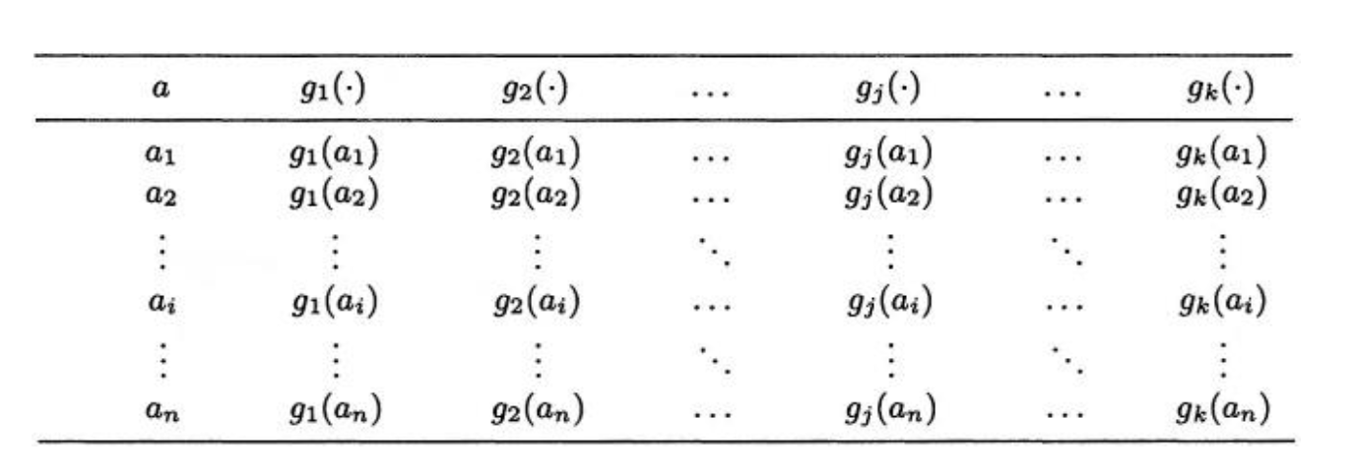
Figure 3.1 – The evaluation table
The quantity g_{j}(a_{i}) gives the evaluation of each alternative for each criterion.
- k weight factor w_{j}. The weight factor prioritizes a criterion by using the responses of the decision makes. Weight factor w_{j} (j= 1, 2, …, k) is calculated and it has a maximum value of 1 (100%) if it is a single criterion that is selected as an important one or in the case of ranking given criteria a value of 0<w<1.
- Preference function P_{j} (ai, ax), (j= 1, 2, ... k). The preference function compares two alternatives based on a specific criterion. In the following example the preference of a_{i} over a_{x} is given for the criterion g_{j}.
- P_{j} (a_{i}, a_{x}) = 0 if there is no preference of a_{i}, over a_{x}
- P_{j} (a_{i}, a_{x}) ≈ 0 if there is a weak preference of a_{i}, over a_{x}
- P_{j} (a_{i}, a_{x}) ≈ 1 if there is strong preference of a_{i}, over a_{x}
- P_{j} (a_{i}, a_{x}) = 1 if there is strict preference of a_{i}, over a_{x}.

Based on the above comparisons and the preferred function chosen for the matrix (the function used for the present research was the Usual Function), the results are provided by the tool. The results are shown in tables as partial ranking in PROMETHEE I, complete ranking in PROMETHEE II or with the help of visualizing them in GAIA (Geometrical Analysis for Interactive Aid). [33, 34, 35]

Terms used
Before the method is outlined, it is important for a few terms to be explained:
- -Alternatives (Actions/ policies)
The alternatives input in Visual PROMETHEE are the different sustainable policies that are to be ranked at the end. In the platform that was used the alternatives are named as actions and are the following:

- Action 1: Sustainable urban mobility plans (SUMP) / sustainable urban logistic plans
SUMPs were introduced in 2013 and are following the simplified clockwise (Figure 3.2) path to achieve a milestone. SUMPs are a reflective and flexible way of achieving the logistic plan involved.
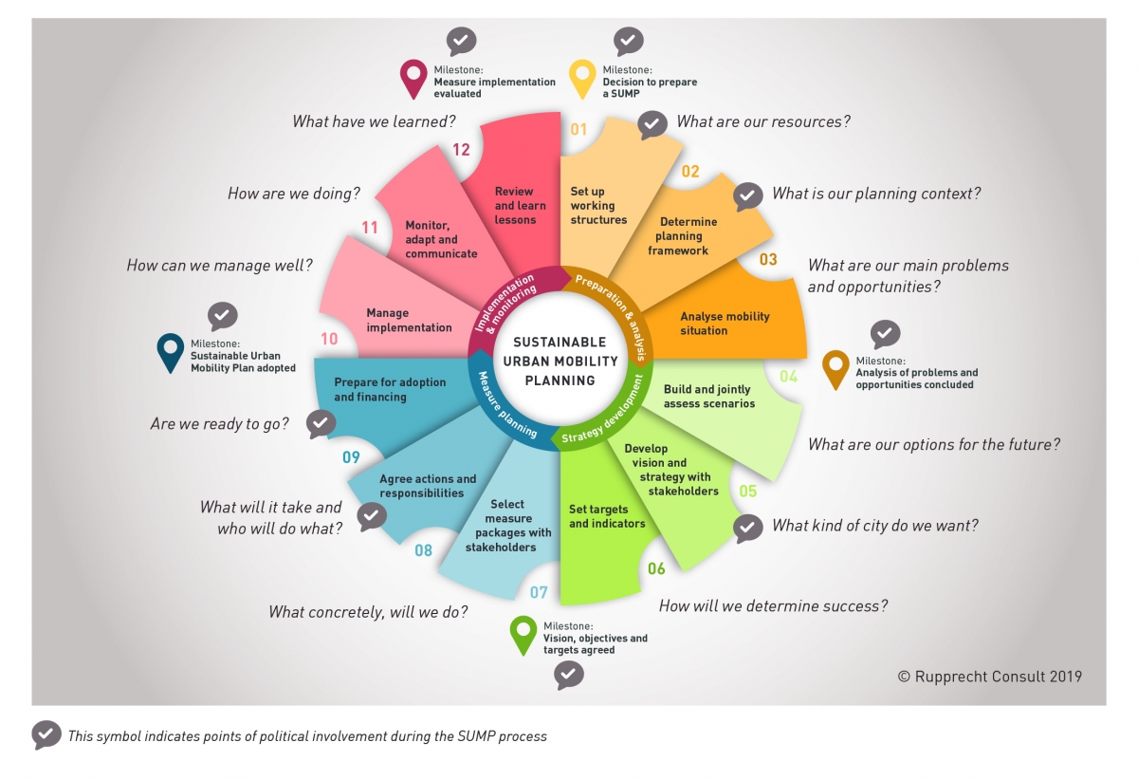
Figure 3.2– The SUMP process
- Action 2: Smart metering/monitoring systems / real-time information
For this policy smart city technology is involved; cameras, Artificial Intelligent (AI), Intelligent Transportation Systems are observing and analyzing traffic data to offer a more well-informed and safer transportation experience to the user.
- Action 3: Increased traffic safety and security - eco driving training
The policies involved in this category include prevention of accidents (through clear marking on the roads, functioning signs etc.) and education of the users to eco-driving.
- Action 4: Mobility plans for school communities
Introducing alternative ways for the students to reach school, whether using active ways of transportation (walking, cycling) or by combining private and public transportation.
- Action 5: Attractive and accessible public spaces
Create spaces that are easily accessible while walking and cycling is a good option for the residents.
- Action 6: Shared mobility services (car, taxi, micro mobility vehicles)
Create the infrastructure needed to accommodate shared micro mobility services alongside with car-pooling and/or shared taxi rides. All those options are going to also prioritize the safety of the users.
- Action 7: E-Charging infrastructures and e-vehicles in public fleets / Update infrastructures with green energy systems (Photovoltaics, Renewable Energy Systems)
Infrastructure to charge electric vehicles will be widely available and an increasing percentage of the public transportation vehicles will be electric.
- Action 8: Mobility management practices
This policy aims to the creation of optimal travel plans for individuals and groups. Those plans probably include multi-modal traveling and active options as well (walking, cycling).
- Action 9: Behavioral change and informative actions
Run campaigns that inform the residences or the visitors on sustainable mobility alternatives. The campaigns are run in a way that is interactive and interesting so it can be as influential as possible.
- Action 10: Low emissions zones / smart parking for cars and micro-mobility vehicles, online parking management
Creation of spaces that only low emissions vehicles are allowed to enter. Update parking management for the users to have a better experience.
- Action 11: Improved and accessible PT services for visitors and residents
Update the PT fleet with vehicles that are using clean energy.
- Criteria
The criteria that are going to be used for this study are the same with the Farmaki et al 2018 and are described in the table below. They are split in 5 categories as shown; Environment, Mobility, Foreign Supported Special Economic Zone Growth, Economy, Local Communities.

Table 3.1 - Description of evaluation criteria
CATEGORY | CRITERION | DESCRIPTION
Environment | a) Energy | Energy consumption, share of conventional fuels
Environment | b) Environmental pollution | Average GHG emissions, noise level, light pollution
Mobility | c) Traffic  conditions | Ratio of alternative transport versus conventional transport, Vehicles occupancy, traffic flow
Mobility | d) Transport infrastructure | Intermodal transport services (the transport of goods in a single unit or vehicle using two or more means of transport to move the load from its origin to its destination)
Foreign Supported Special Economic Zone Growth | e) Experience for foreigners | No. of visitors, foreign investments related to the SEZ policies, number of business events
Economy | f) Service finance | Cost of new services and infrastructure
Economy | g) Local economy | Affordability of public transport services, financial gain by new services and infrastructures
Local Communities | h) Safety | Level of perceived safety and security, emergency systems in place
Local Communities | i) Users  satisfaction | Level of satisfaction and level of acceptance of the mobility policies
Local Communities | j) Accessibility | Level of accessibility of transport services, accessibility of public spaces
Ideally, a sustainable mobility strategy will optimize the value for the green criteria and reduce the red criteria.
- Stakeholders Groups
As described in the introduction, there are 6 different groups that were approached to contribute to the policies ranking. In the platform of PROMETHEE each group is called a Scenario. The individuals were approached in the city of Shenzhen with the usage of extensive networking and the help of the following groups: LGBTQAI+ community, Black people in Shenzhen, Expat women in Shenzhen, Shekou Tennis community, F45 Guangdong, Greek consulate of Guangdong, BASIS International Schools, International Teachers in China, BISZ Library, BISZ Gender Study Club.
The individuals who contributed with answers are to stay anonymous.
Below can be found a short description of each group, and the position of the different individuals who participated in this research. The questionnaire was given to a way bigger number of willing participants but if they didn’t return it by March 2022 their answers were not included in the PROMETHEE tables and their job description cannot be found below.

Table 3.2: Questionnaire Participants
Stakeholders Group | Company
PT Operators | Shenzhen Bus Group
Local Authorities | CN-HK Borders Check
Local Authorities | Traffic police officer
Academic Institutions | SUS-Tech
Academic Institutions | CUHK
Mobility Experts | IN2LOG
Mobility Experts | Hellenic Agora
Mobility Experts | Amazon
Mobility Experts | Shekou School of Arts (transportation admin)
Environmental Groups | China Design Group
Environmental Groups | Keru
Local Communities | Expat Women of Shenzhen Association
Local Communities | Volunteer in numerous organizations
Local Communities | Local Political figure

- Classifications tables
The participants were asked to rank the criteria from most important to least important. The instruction was available in English and in Chinese. Below you can find the instructions in Chinese and the action point in English.
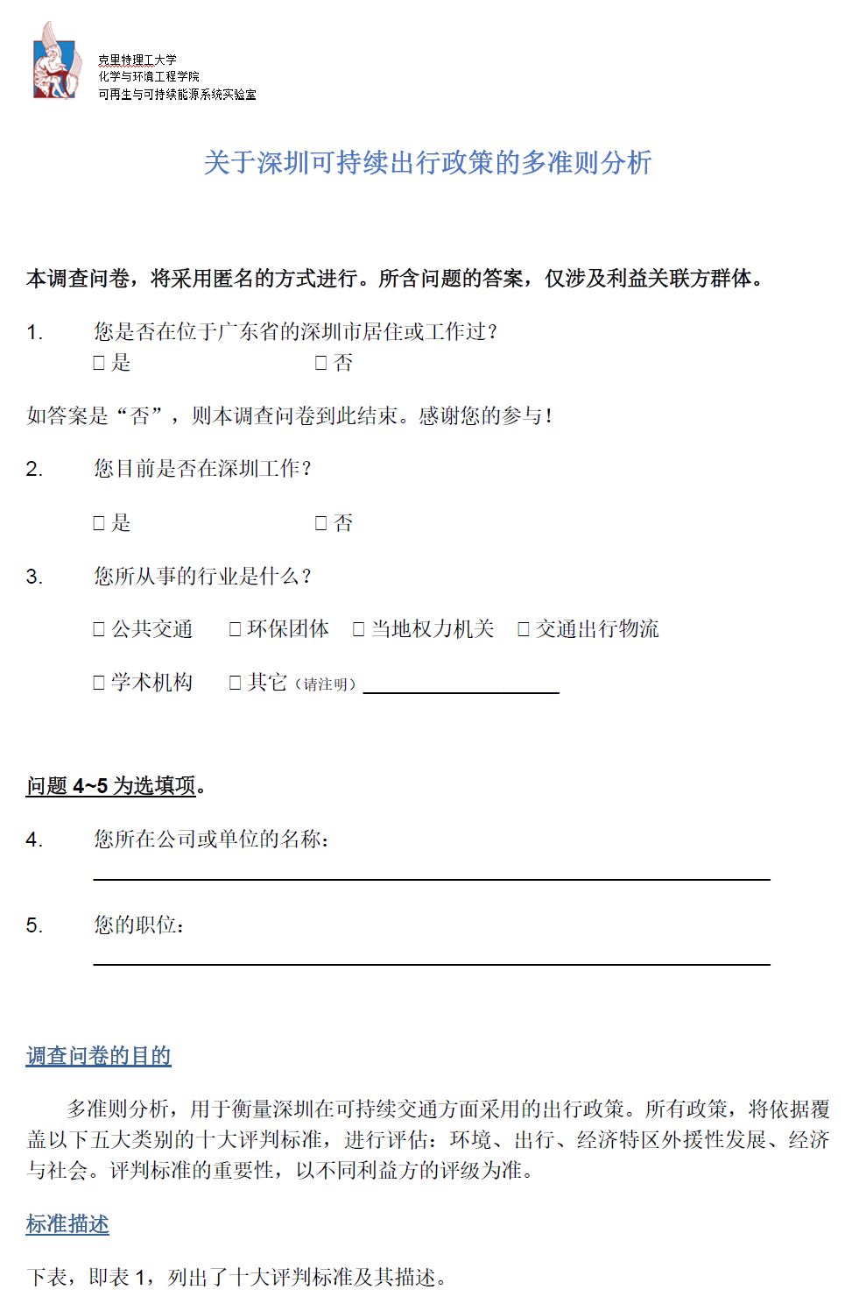
Figure 3.3 – The Chinse PROMETHEE questionnaire
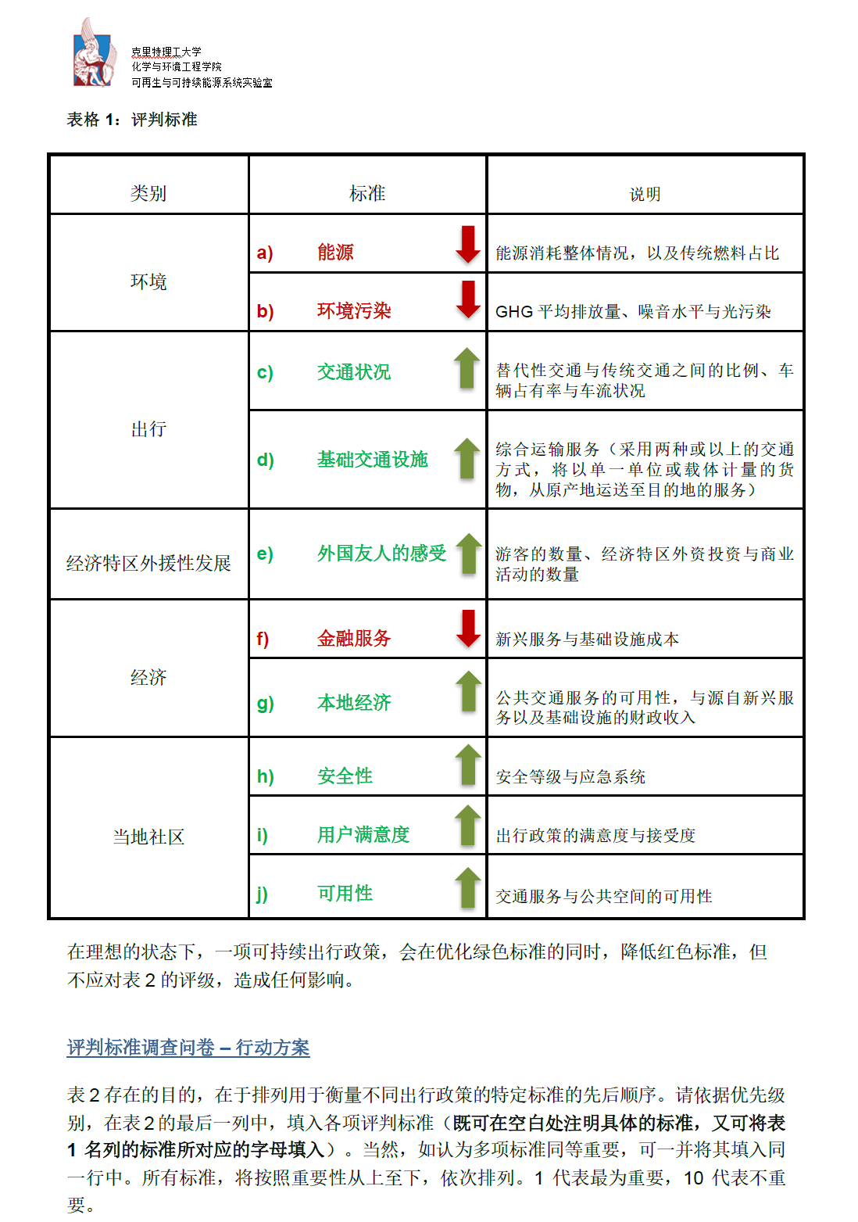
Figure 3.4 – Description of evaluation criteria in Chinese

- Questionnaire for the evaluation of criteria
The following Table was to be completed by the stakeholder group’s representative. The said table -from now on will be referred to as classification table- was completed based on detail instructions given to the participant. The outline of the instructions focused on the classifying based on their personal preference and that they were allowed to classify more than one criteria in the same order of preference.
Table 3.3 - Criteria Evaluation Form
Criteria Evaluation
 | Order of preference | Criteria
High importance  Low importance | 1.
High importance  Low importance | 2.
High importance  Low importance | 3.
High importance  Low importance | 4.
High importance  Low importance | 5.
High importance  Low importance | 6.
High importance  Low importance | 7.
High importance  Low importance | 8.
High importance  Low importance | 9.
High importance  Low importance | 10.

The above table was completed and submitted to the researcher in a variety of ways, depending on how comfortable the participant was to share their identity. Below are presented different responses.

Table 3.4 – Response collected through Greek consulate of Guangdong

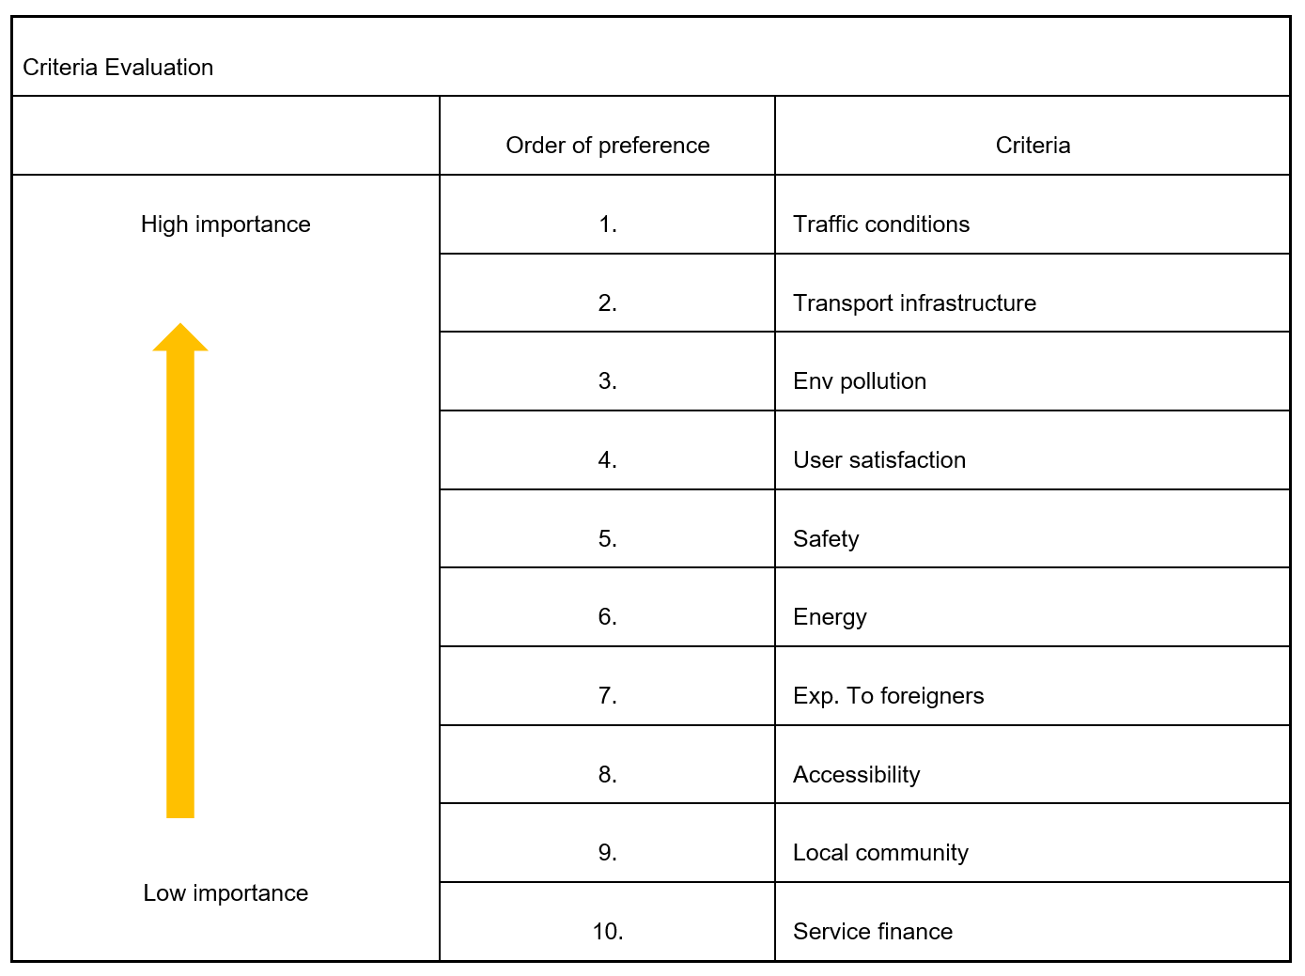


Figure 3.5 – Response collected through BISZ Library

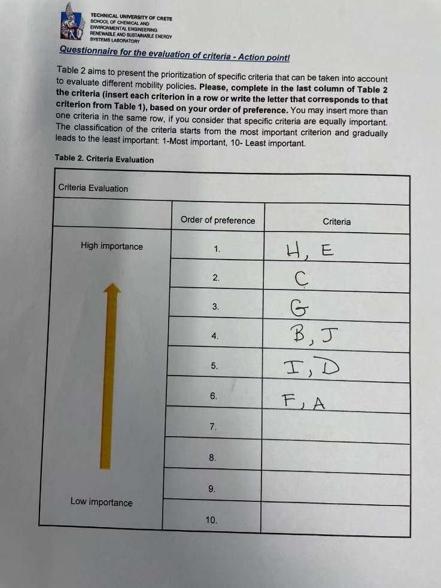
Figure 3.6 – Response collected through Expat Women in Shenzhen

- Weights
Based on the classification table results, a relative weight was calculated for each stakeholder group. An example for how the relative weight was calculated can be found below.
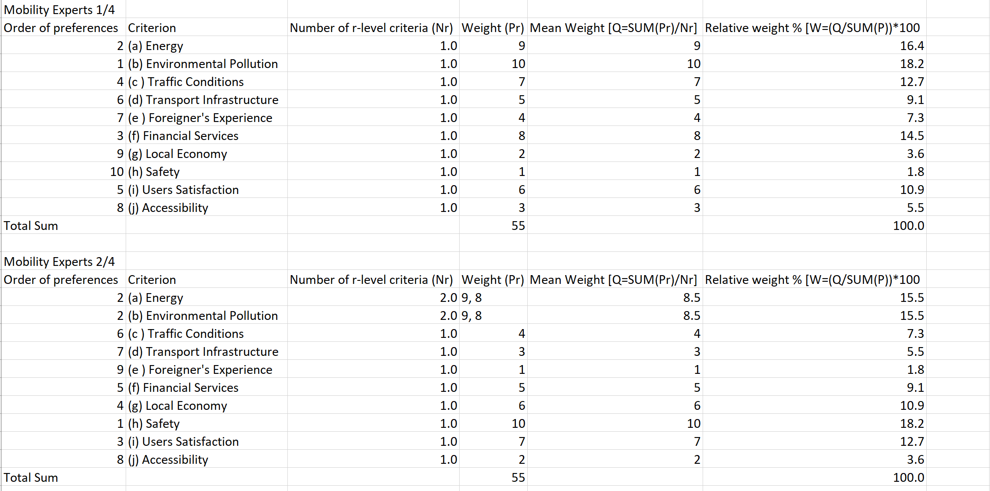

Figure 3.7– Relative weights calculations for Mobility Experts group

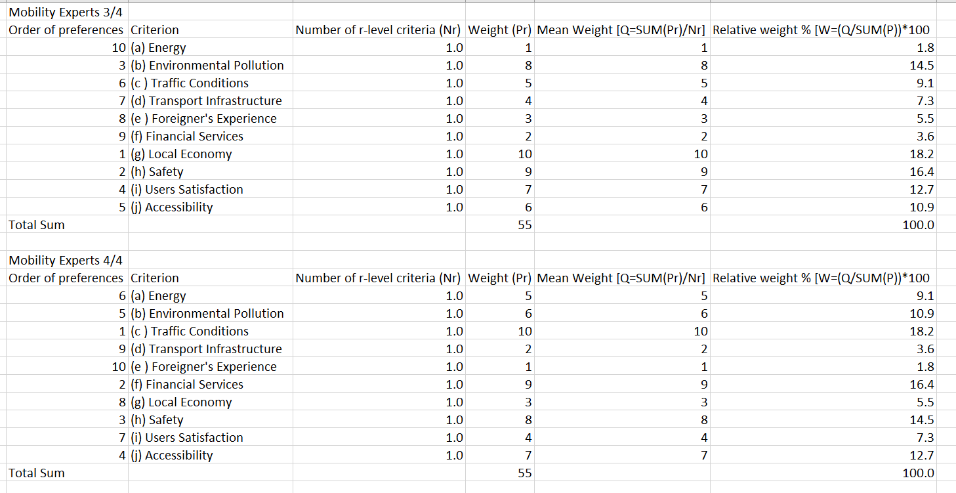

Figure 3.8– Relative weights calculations for Mobility Experts group

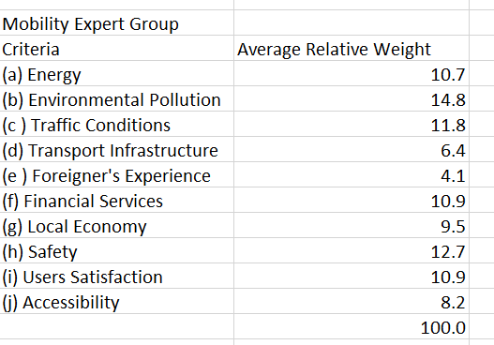
Figure 3.9– Relative waves calculations for Mobility Experts group

- Evaluation Table
The table below gives an evaluation of each alternative based on each criterion. The table below is the result of extensive bibliographical review and it was written and used by Farmaki (2018). In the present study, the same table was used so that the results of the two studies can be compared.

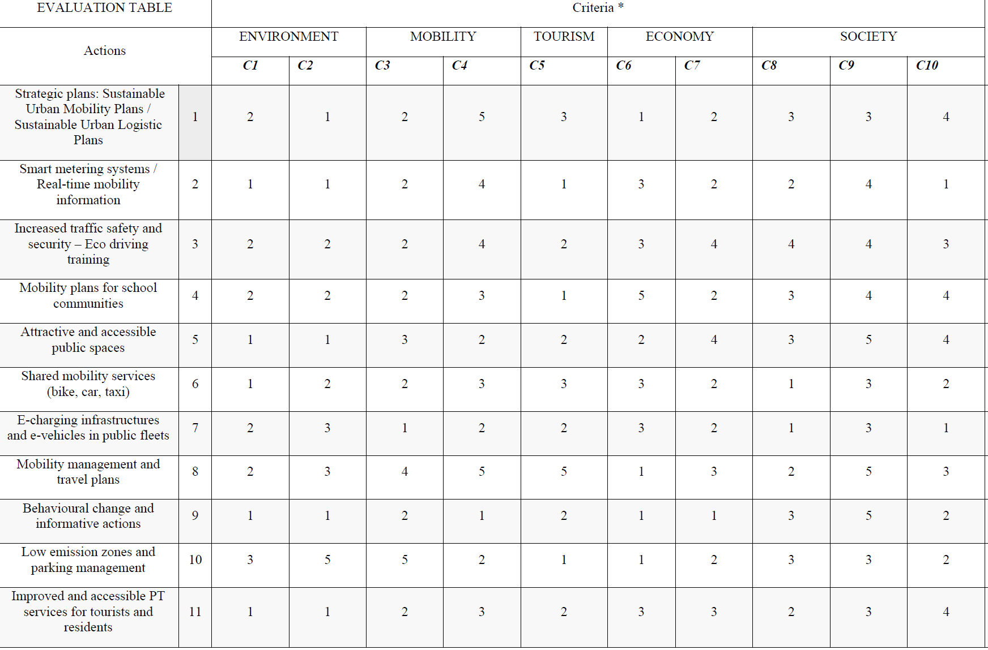
Figure 3.10 - Evaluation of Actions based on the different Criteria

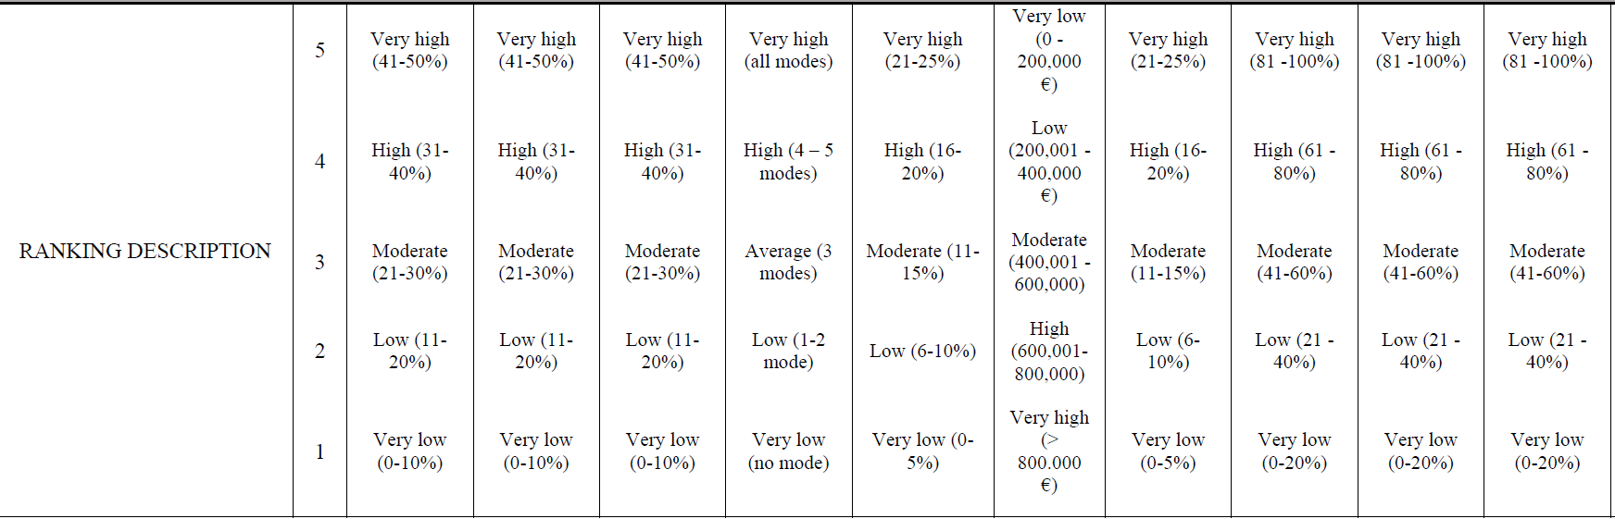
Figure 3.11 - Ranking Description
- Preference Flow
The outcome of PROMETHEE is given based on the values Phi+ and Phi-. Preference Flow Phi+ indicates how one alternative is stronger than another, while value Phi- indicates how one alternative is less optimal than another. To simplify this concept, value Phi net is used which is given by (Phi+)-(Phi-) and is used to rank the alternatives.

The above information gives an initial description of the method that was used by the authors.

3.3. Steps Followed
The steps that were followed can be found below:
Step 1: The stakeholder groups and policies were identified. The classification table with guidelines and translation were written.
Step 2: Participants were approached, and answers were collected.
Step 3: The evaluation table was built on PROMETHEE Platform. The criteria, actions and different stakeholder groups sheets were formed. The bibliographical evaluation of the actions and the relative weights of the questionnaires were added in the matrix.
Step 4: PROMETHEE II gives complete ranking of all the criteria for each stakeholder group and for all of them together using the net preference flow value.
Step 5: Walking Weight function was used to see the impact of the weight factors on the final results.
Step 6: Comparison of results with Farmaki,2018.

Results
The initial results were the relative weights for each of the stakeholders’ groups, taken from the analysis of the classification tables.
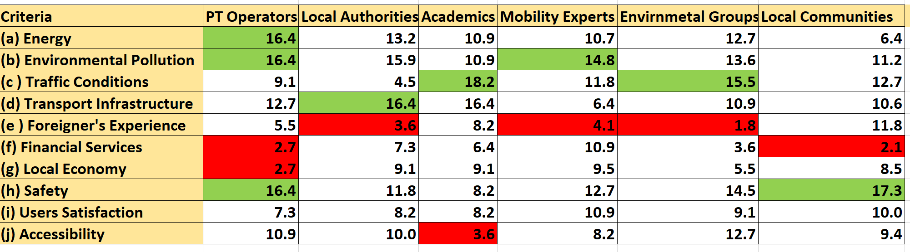
Table 4.1 - Relative Criteria Weights for each stakeholders group.

The Criterion with the maximum interest for the specific group is marked with green while the one that seems to have the least interest for that specific group is marked with red.
By inserting information from weighs and the evaluation table resulting from the literature review, the research gets 7 different evaluation matrixes; 6 for the stakeholder groups and one for all of them combined. The evaluation matrix for all the stakeholder groups is shown below.
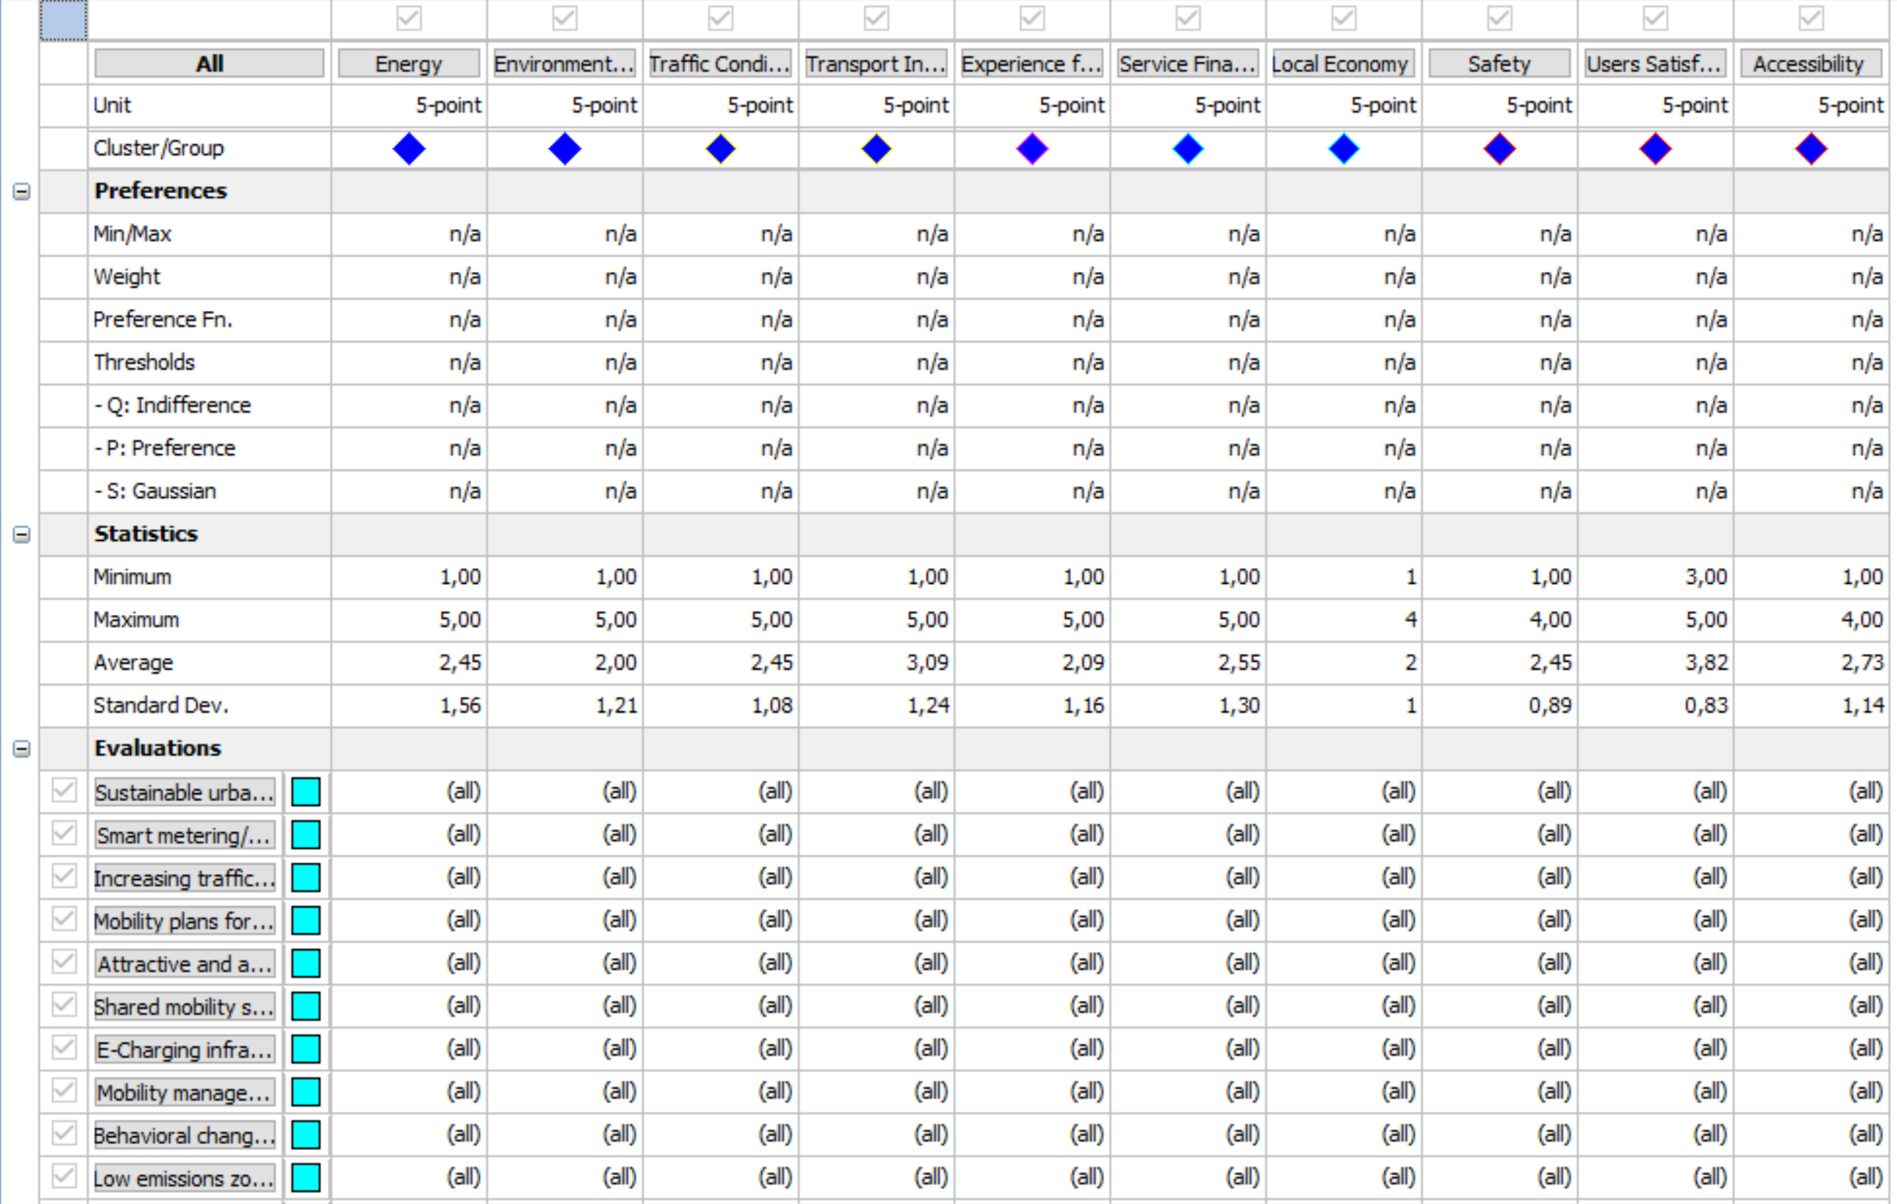
Figure 4.1 - Evaluation matrix

Figure 4.1 comes as a result of all stakeholder groups. Below are represented the results of each individual group.
PT Operators
For this group, the most important criteria belong in the environment category, with Criterion a, Energy and Criterion b, Environmental Pollution and Local Communities, Criterion h, Safety to come first with 16.4%. From category Economy, both Criterion Financial Services and Local Economy (Criteria f and g) came last with 2.7%.
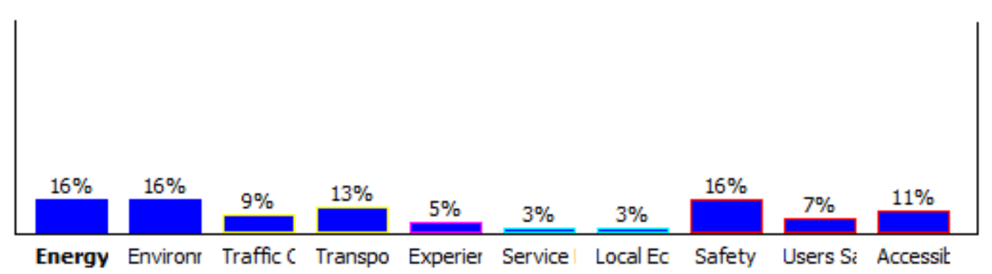
Figure 4.2 - Weights for PT Operators
The two optimal Actions seem to be Action 3 and 8, Increasing traffic safety and security/ eco-driving training and Mobility Management Practices. The action with the minimum net Phi, therefore the one that is the least optimal was Action 7, E-charging infrastructure and e-vehicle public transportation fleet.
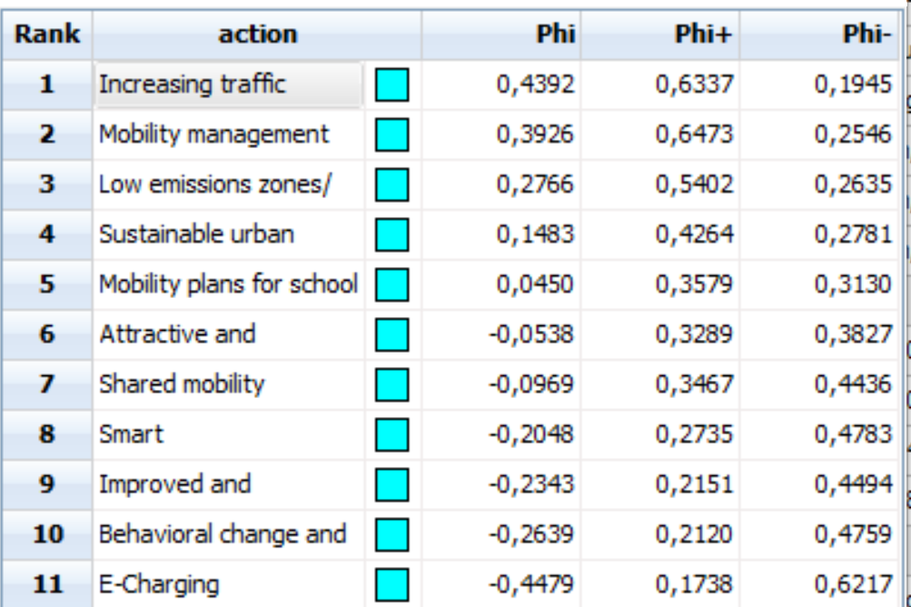
Figure4.3 - PROMETHEE Flow Table for PT Operators: 1. Increasing traffic safety and security, 2. Mobility management practices, 3. Low emission zones/ smart parking, 4. SUMP, 5. Mobility Plans for schools, 6. Attractive and accessible public spaces, 7. Shared Mobility Services, 8. Smart metering/ monitoring systems, 9. Improved and accessible PT services, 10. Behavioral change and informative actions, 11. E-Charging Infrastructure and e-vehicles in public fleets.
Local Authorities
Based on the classification tables, the Local Authorities group prioritizes the mobility criteria with Criterion d: Transport Infrastructure to get 16.4% and environment Criterion b: Environmental pollution to come up next with 15.6%. The criterion with the least weight is the Foreign Supported SEZ growth with (Criterion e: Foreigner’s Experience) with 3.6%.

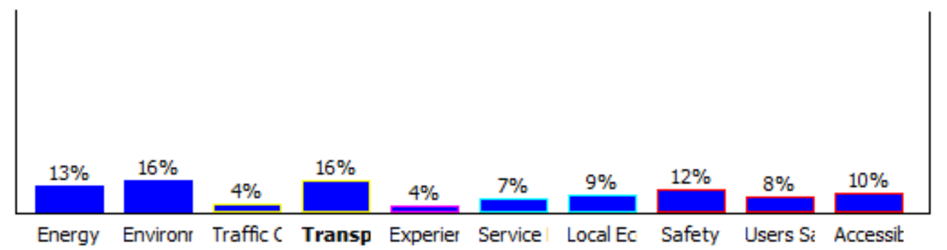
Figure 4.4 - Weights for Local Authorities
Based on the Preference flow table, the two policies that seem to be optimal are Action 8 and 3, Mobility Management Practices and Increasing traffic safety and security/ eco-driving training. The action that is the least favorable is Action number 7, E-charging infrastructure and e-vehicle public transportation fleet.

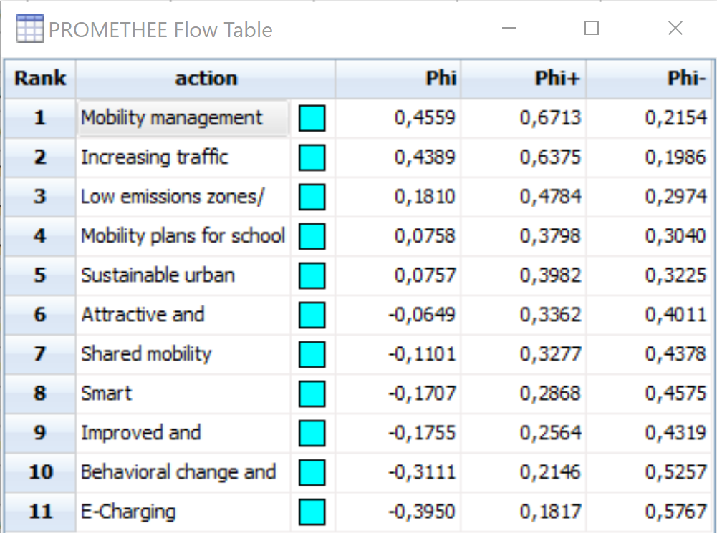
Figure 4.5 - PROMETHEE Flow Table for Local Authorities: 1. Mobility management practices, 2. Increasing traffic safety and security, 3. Low emission zones/ smart parking, 4. Mobility Plans for schools, 5. SUMP, 6. Attractive and accessible public spaces, 7. Shared Mobility Services, 8. Smart metering/ monitoring systems, 9. Improved and accessible PT services, 10. Behavioral change and informative actions, 11. E-Charging Infrastructure and e-vehicles in public fleets.

Academic Institutions
Academics appear to value the most the Mobility, as Criterion c, Traffic Conditions and Criterion d, Transport Infrastructure got relative weight of 18.2% and 16.4%, while in the last place Local communities can be found. Criterion j from LC, Accessibility got a 3.6%.

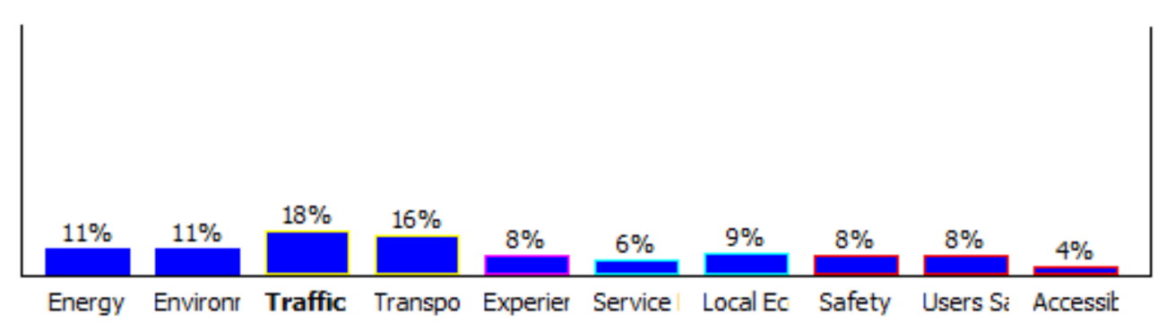
Figure 4.6 - Weights for Academic Institutions
The policy with the maximum Phi value is Action 8, Mobility Management Practices. It is significant optimal to the second one which appears to be Action 3, Increasing traffic safety and security/ eco-driving training. The action that is the least favorable is for this group as well Action number 7, E-charging infrastructure and e-vehicle public transportation fleet.
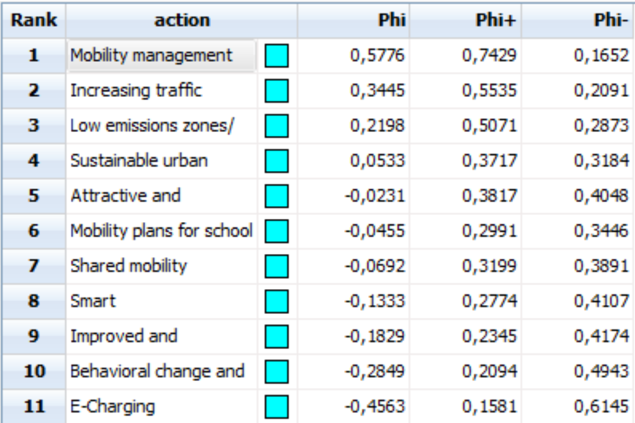
Figure 4.7- PROMETHEE Flow Table for Academic Institutions: 1. Mobility management practices, 2. Increasing traffic safety and security, 3. Low emission zones/ smart parking, 4. SUMP , 5. Attractive and accessible public spaces, 6.Mobility Plans for schools, 7. Shared Mobility Services, 8. Smart metering/ monitoring systems, 9. Improved and accessible PT services, 10. Behavioral change and informative actions, 11. E-Charging Infrastructure and e-vehicles in public fleets.

Mobility Experts
For Mobility Experts, people that are working with the logistical aspect of transferring goods and groups, the most important Criterion was b in the Environment category, Environment Pollution with 14.8%. The second favorable was Criterion h, Safety with 12.7% and the least favorable was Criterion e, Foreigners Experience with 4.1%.
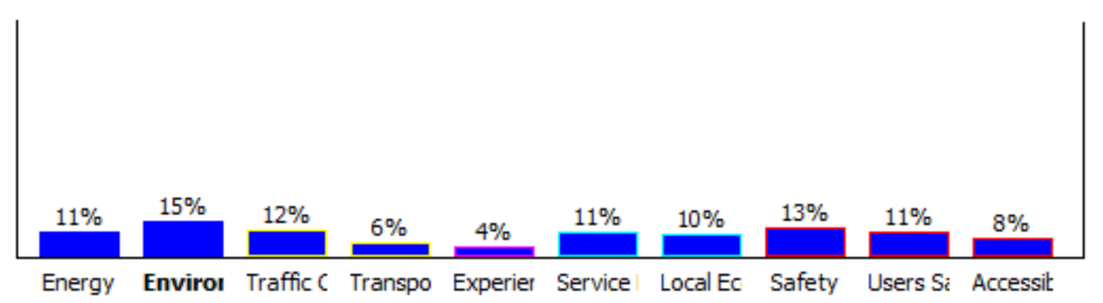
Figure 4.8 - Weights for Mobility Experts
The two optimal actions are Action 8 and 3, Mobility Management Practices and Increasing traffic safety and security/ eco-driving training. The action with the lowest Phi is number 7, E-charging infrastructure and e-vehicle public transportation fleet.
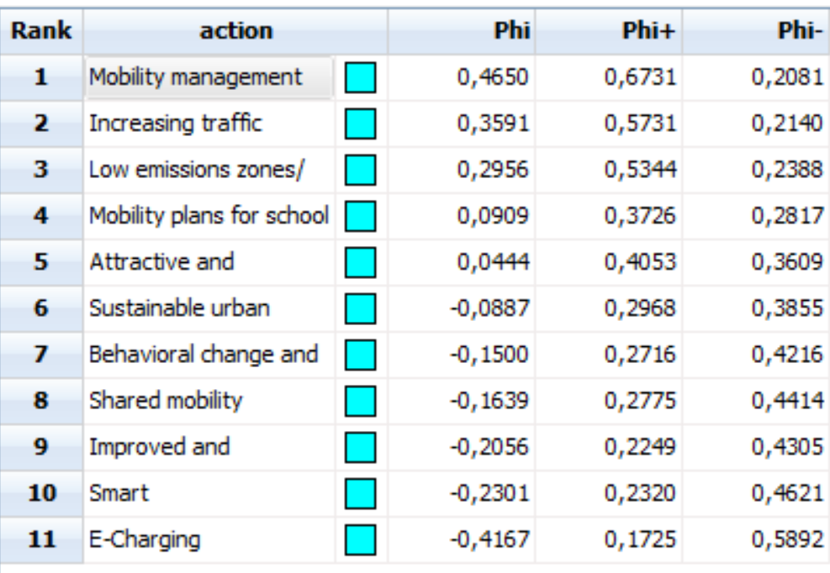
Figure 4.9 PROMETHEE Flow Table for Mobility Experts: 1. Mobility management practices, 2. Increasing traffic safety and security, 3. Low emission zones/ smart parking, 4. Mobility Plans for schools, 5. Attractive and accessible public spaces, 6. SUMP, 7. Behavioral change and informative actions, 8. Shared Mobility Services, 9. Improved and accessible PT services, 10. Smart metering/ monitoring systems, 11. E-Charging Infrastructure and e-vehicles in public fleets.

Environmental Groups
Interestingly, for the people that work in environmental groups the dominant criteria are Criterion c and h, Traffic Condition (15.5%) and Safety (14.5%). According to the Relative Weights table, Criterion e, Foreigner’s Experience come at last place with 1.8%.

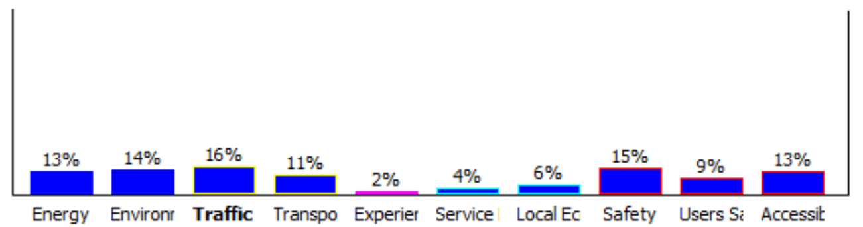
Figure 4.10 - Weights for Environmental Groups
Similarly, to the previous groups, for Environmental Group Actions 8 and 3 appear to be the optimal ones. Action number 7, E-charging infrastructure and e-vehicle public transportation fleet comes in last place with maximum Phi- and minimum Phi+.
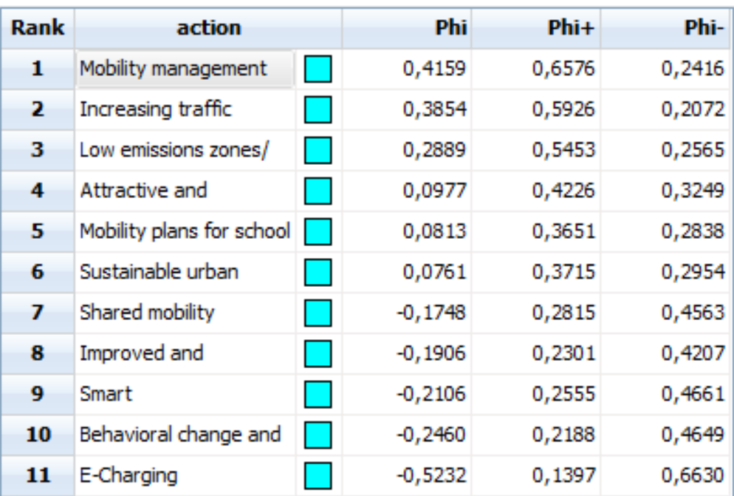
Figure 4.11 - PROMETHEE Flow Table for Environmental Groups: 1. Mobility management practices, 2. Increasing traffic safety and security, 3. Low emission zones/ smart parking, 4. Attractive and accessible public spaces, 5. Mobility Plans for schools, 6. SUMP, 7. Shared Mobility Services, 8. Improved and accessible PT services, 9. Smart metering/ monitoring systems, 10. Behavioral change and informative actions, 11. E-Charging Infrastructure and e-vehicles in public fleets.

Local Communities
Finally, for the Local Communities’ representatives, Safety and Traffic Conditions appears to be the top priority with relative weights of 17.3% and 12.07% accordingly. It is interesting to notice that Foreigner’s experience comes close third with 11.8% and this group is the only one that gives this criterion credit. The weakest criterion comes from the Economy category and is Financial Services with 2.1%.

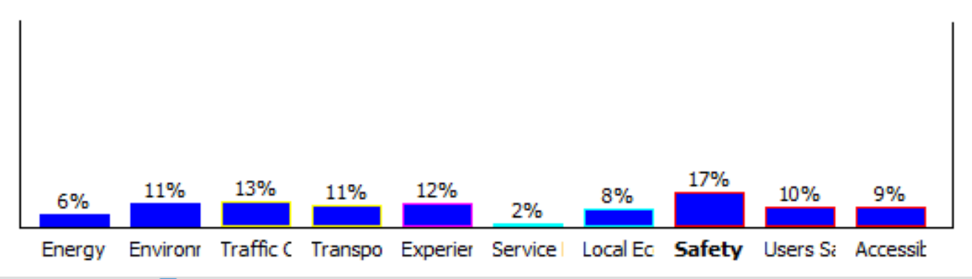
Figure 4.12 - Weights for Local Communities
Regardless the differences in priorities of this group, the dominant actions remain Action 8 and 3, Mobility Management Practices and Increasing traffic safety and security/ eco-driving training. According to the table below, Action number 7, E-charging infrastructure and e-vehicle public transportation fleet is the one that would be the last to consider.
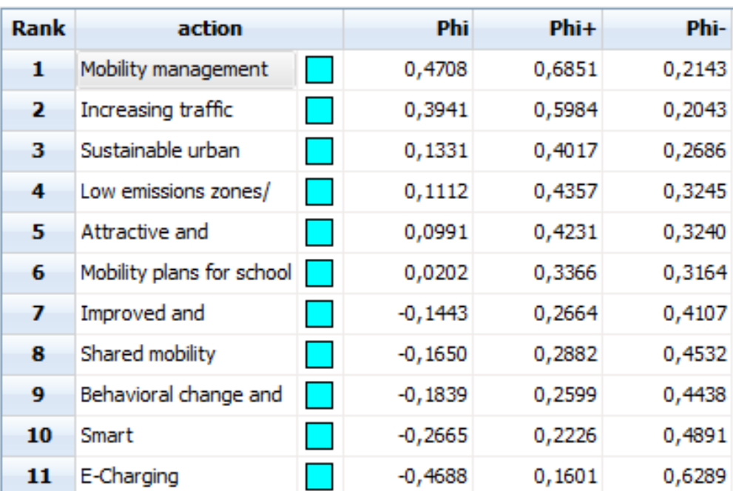
Figure 4.13- PROMETHEE Flow Table for Local Communities: 1. Mobility management practices, 2. Increasing traffic safety and security, 3. SUMP , 4. Low emission zones/ smart parking, 5. Attractive and accessible public spaces, 6. Mobility Plans for schools, 7. Improved and accessible PT services, 8. Shared Mobility Services, 9. Behavioral change and informative actions, 10. Smart metering/ monitoring systems, 11. E-Charging Infrastructure and e-vehicles in public fleets.

Looking at the “All” Sheet that combines the six different groups, a complete ranking can appear (Figure 4.14).
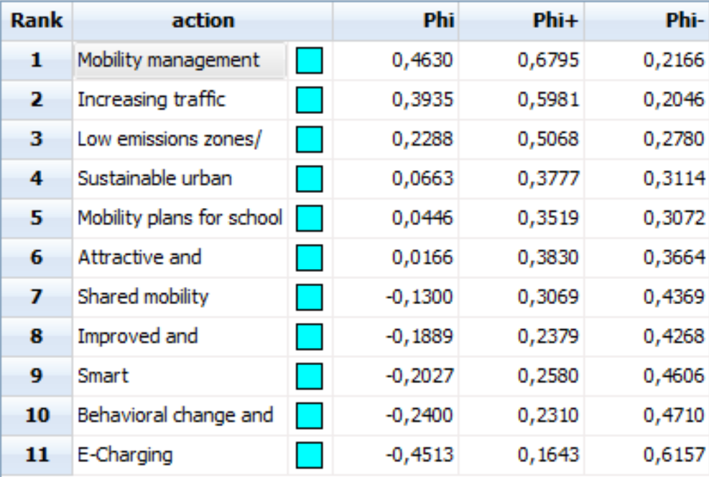
Figure 4.14 - PROMETHEE Complete Flow Table: 1. Mobility management practices, 2. Increasing traffic safety and security, 3. Low emission zones/ smart parking, 4. SUMP, 5. Mobility Plans for schools, 6. Attractive and accessible public spaces, 7. Shared Mobility Services, 8. Improved and accessible PT services, 9. Smart metering/ monitoring systems, 10. Behavioral change and informative actions, 11. E-Charging Infrastructure and e-vehicles in public fleets.

The ranking above comes as no surprise for the first two and the last positions as they are the same with every single one of the stakeholder groups. More specifically the most optimal scenario is Mobility Management and the one that would not be recommended is E-Charging.

Discussion and Conclusions
The main objective of this study is to find the optimal sustainable mobility policies for the city of Shenzhen, based on the literature review of said policies and the evaluation of a set of criteria done by six groups of experts. The literature review was done by Farmaki (2018) and the second objective of this study is to compare the finding for Shenzhen, with those that Farmaki gathered for a mid-sized Mediterranean city. The main pillars for the observation that can be made are the following: Policies ranking, Weights and Challenges.
  - Policies ranking
The policies ranking is given with two different ways: by the function of Scenario Comparison (Figure 5.1) and by the PROMETHEE Flow Table that was mentioned above (Figure 4.14). The Scenario Comparison has a more detailed approach as it visualizes for the user to see the connection between the different Scenarios (stakeholders’ groups). The Preference Flow is shown for each group and it was linked with a turquoise line with the same action on the next group.
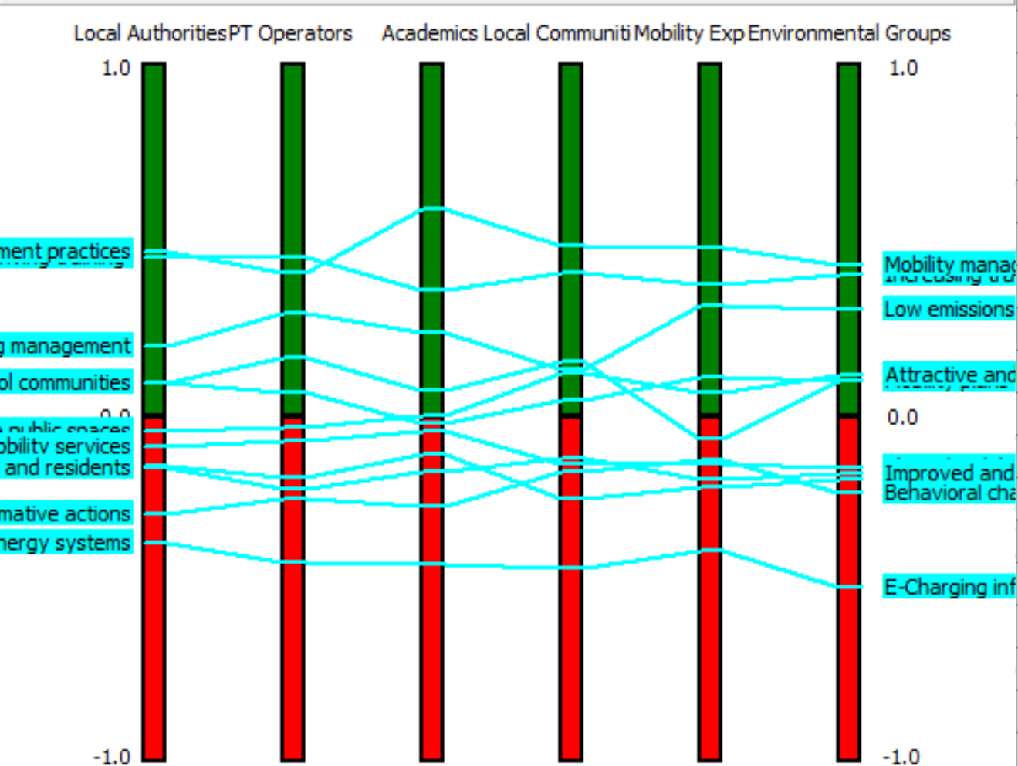
Mobility management/ Increasing traffic safety Low emission zones
SUMP / Mobility Plans for schools / Attractive public spaces
Shared Mobility Services /Improved and accessible PT services / Smart metering systems/ Behavioral change and informative actions
E-Charging Infrastructure and e-vehicles in public fleets

Figure 5.1 - Scenario comparison PROMETHEE II

From Figure 5.1 is obvious that the first 3 actions (Mobility management, Increase of traffic safety and low emission zones/ smart parking and micro mobility) are dominant across almost all of the Scenarios. Action#8 is the first option for all groups other than PT Operators and Action#10 is the third one for all other than Local Communities. Action#7 is consistently the last option for all the scenarios. The remaining seven actions have different position in different groups.
When observing the Figure 5.1 it is clear that the first three and the last one preferable actions are in line with the observations that were made for the different scenarios.
Working towards the goal of comparing the results for the mid-size Mediterranean city to Shenzhen, below are given the results from Farmaki. She had split her participants to EU and GR.
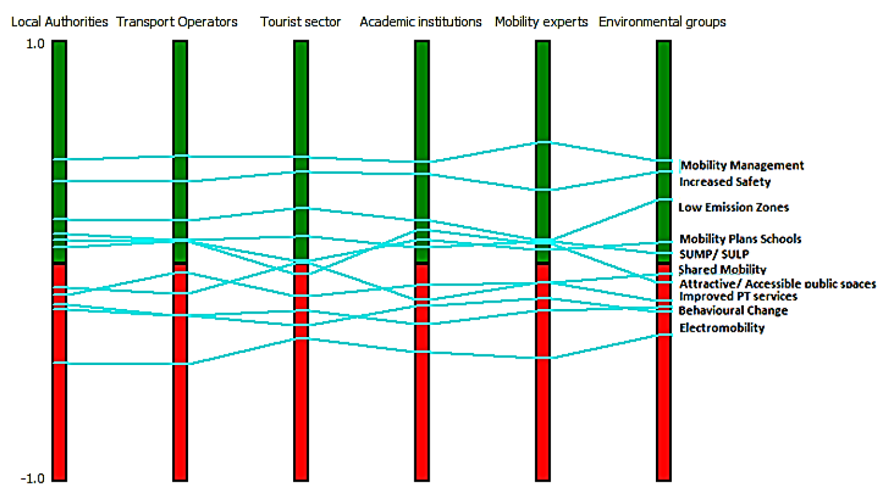
Figure 5.2 - Scenario comparison PROMETHEE II ranking for EU Stakeholder groups
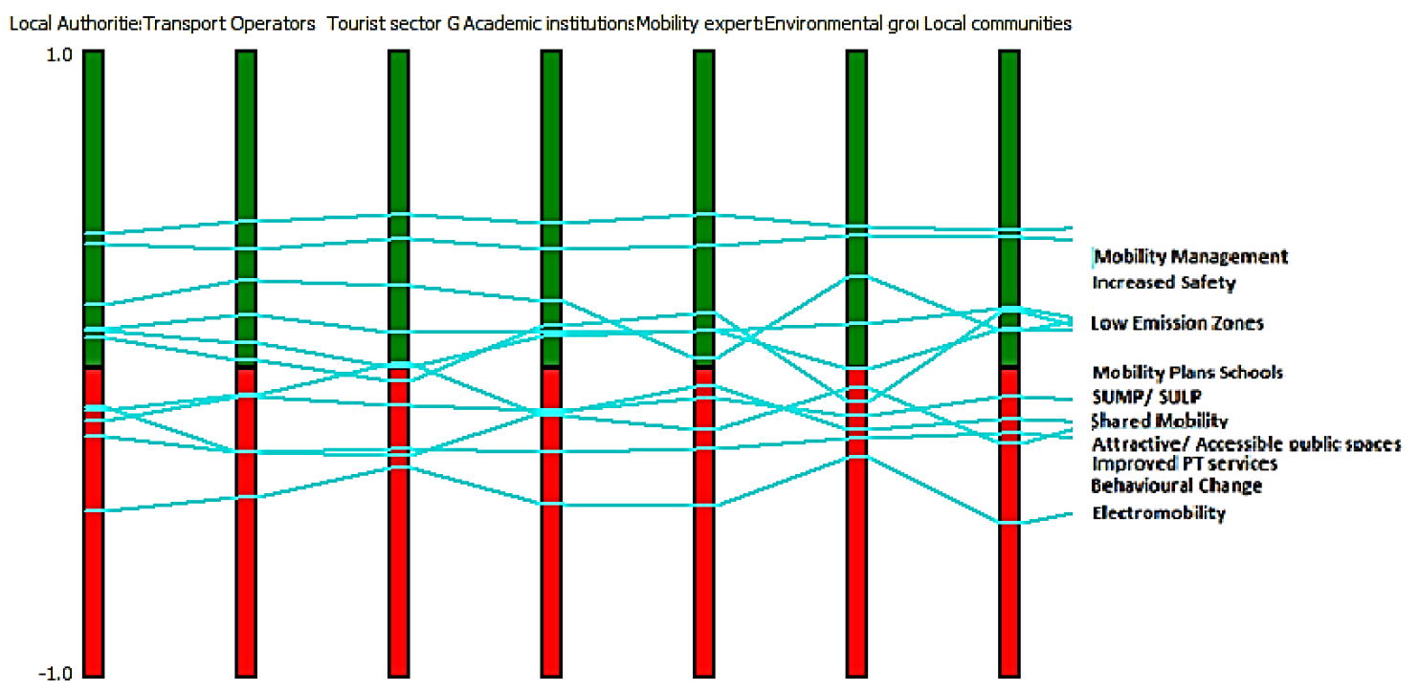
Figure 5.3 - Scenario comparison PROMETHEE II ranking for GR Stakeholder groups

The results that we are focused on (first three and last one on the ranking) from all the different stakeholders appear to be the same. Action#10 though, seems to be less stable for the GR Participants in comparison to the others, as Mobility Experts and Local Communities had it in lower rank. That didn’t seem to affect the total ranking for GR (and EU) that remained the same with the Shenzhen results (Figure 5.1).
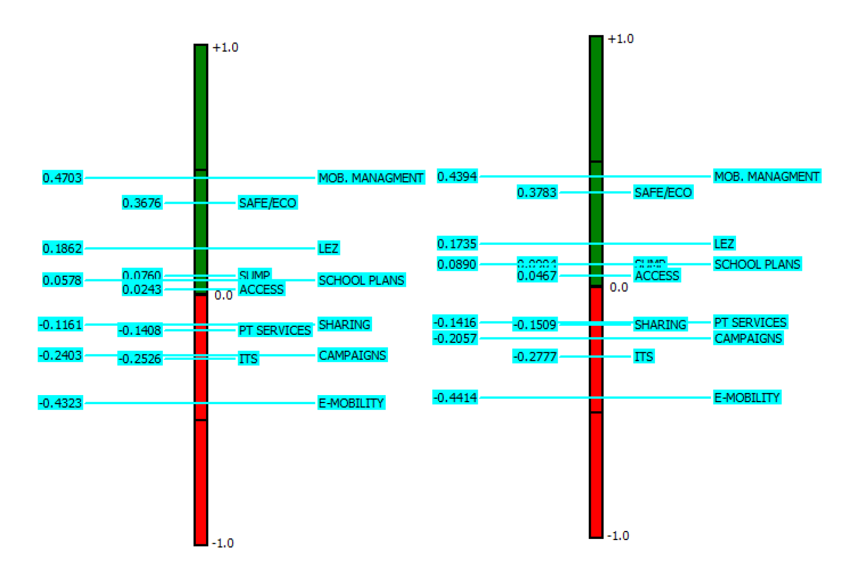
Figure 5.4 - PROMETHEE II Policies Ranking EU and GR
  - Weights
Considering how the ranking appears to be that consistent across the different groups, it is important to look at the one thing that differentiates between the said groups: weights. Although the criteria were slightly changed (instead of tourists’ experience in Rethymnon, we had Foreigner investors’ experience in Shenzhen) to suit the Chinese approach a comparison can be made on what the different groups valued and what they did not. It has already been mentioned what criteria the different stakeholder groups valued more (Table 4.1). Weight measurements from Table 4.1 were used to create a quantitative table that describes the priorities of the different scenarios.

Table 5.1 - Priorities and least important criteria (Shenzhen)
Stakeholder Group | Priority Criteria | Least Important Criteria
PT Operators | Energy,  Environmental Pollution,  Safety | Financial Services,  Local Economy
Local Authorities | Transport Infrastructure,  Environmental Pollution | Foreigner’s Experience
Academic Institutions | Traffic Conditions,  Transport Infrastructure | Accessibility
Mobility Experts | Environmental Pollution,  Safety | Foreigner’s Experience
Environmental Groups | Traffic Conditions,  Safety | Foreigner’s Experiences,  Financial Services
Local Communities | Safety | Financial Services

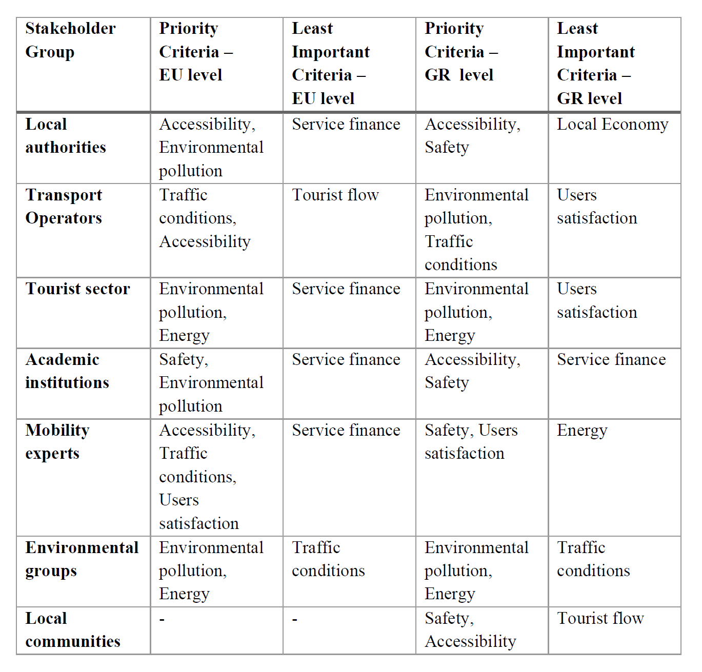
Figure 5.5 - Priority and least important criteria for EU and GR stakeholder groups.
Looking the different groups, the following observations can be made:
- PT Operators have completely different approach on everything, the only common point is prioritizing Environmental pollution (GR and CN).
- Local Authorities have only one common point and that is, again, the environmental pollution (EU and CN).
- Academic Institutions have nothing in common, as the CN part seems to value Mobility criteria the most and Local Communities, while the Europeans seem to value Local Communities the most and Economy criteria the least.
- The only common point for Mobility Experts appears to be Safety (CN and GR).
- The Environmental Groups in China value the most the Traffic Conditions which is the criterion that the European Environmental groups value the least.
- Local Communities for both the China part and the Greek part agree that Safety should be the number one priority.
The interesting thing about the above observations is that even if the differentiating factor between Shenzhen and Mediterranean city has different values, the final results for the action ranking are almost identical. To understand the reasoning behind that, it is useful to facilitate the “Walking Weights” function of PROMETHEE. This function alternates the ranking by eliminating the weighting effect. It does that by giving a default weight of 100/(number of criteria) weight to each of the criterion. For this study, that will be 10% to all of them.
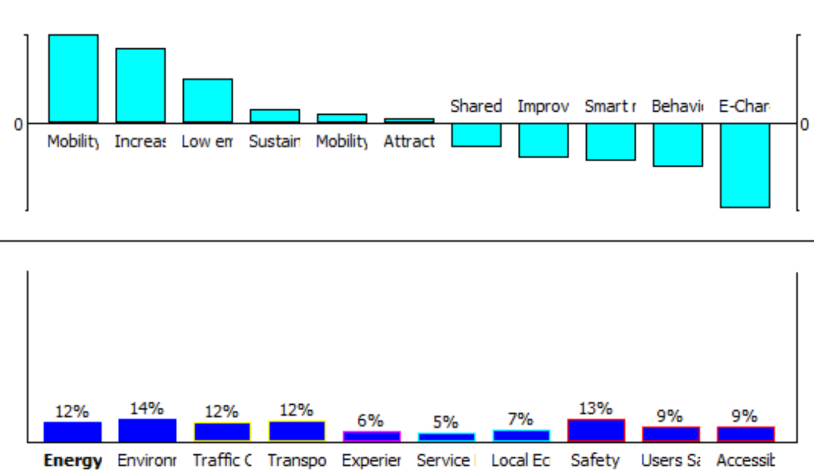
Figure 5.6 - Walking weight for comparison charts

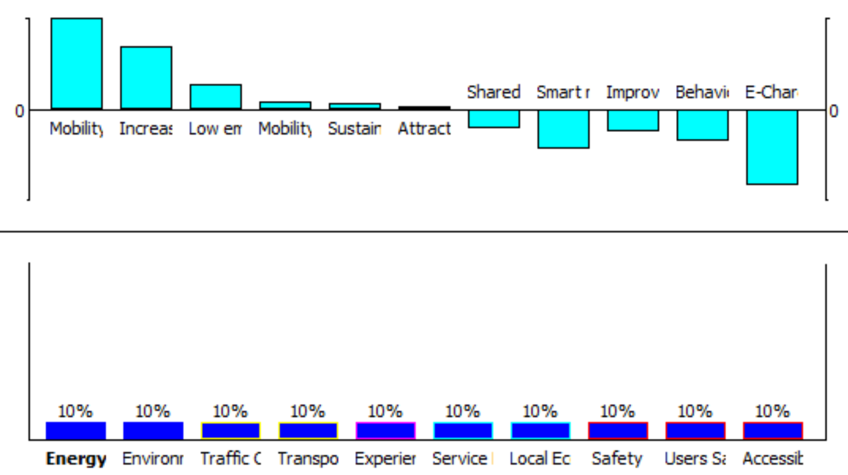
Figure 5.7 - Walking Weights for 10% weight per criterion

It is noticed that nothing is changed for the best ranked or the worst ranked actions by changing the weights. The actions that seemed to swap are Action#1 and #4 (Sustainable urban mobility plans / sustainable urban logistic plans <-> Mobility plans for school communities) and Action#6 and #11 (Shared mobility services (car, taxi, micro mobility vehicles <-> Improved and accessible PT services for visitors and residents).
  - Challenges
This research has been an exciting and a meaningful experience for the author, but there are things that made it the process challenging and those were PROMETHEE and the collecting the comparison tables.
PROMETHEE is a very useful tool that is widely used, there is a lot of resources about it online and is free. Although it takes time to get used to the variables and the action points of the platform, the instructions and the online tutorials were very straightforward. For reasons that the author was not able to find out, there were moments that the platform would not respond and would not complete the functions, thing that was very easy to troubleshoot by closing the program and starting again. Unfortunately, I was unaware at the beginning of filling the evaluation table that this is the case so I lot of time was spent thinking that the variables filled in were wrong.
The biggest challenge was the collection of the classification tables. The original group of 18 participants (the number of answers needed were set by the supervisor of this research and myself to 12) had agreed that will complete the table and the table was shared with them early December. From that group less than half end up completing it and new people had to be found and more reminders and requests had to be sent out. The final answer was received in February and the total number was 14. For the PT Operators group only one answer was collected although many individuals had agreed in answering it, but the study had to move forward regardless this fact.
Another challenge was the isolation that the pandemic brought to the community of Shenzhen. The questionnaires and the evaluation tables were collected late 2021. In the city of Shenzhen there were no COVID cases since the beginning of 2020, situation that was changed close to the period when the answers were collected. Because of the “zero-policy” that was implemented and still is at the time as soon as cases were observed in the city, social distancing and avoidance of social events were implemented. That had as a result to make the distribution of questionnaires to a wider circle of acquaintances, or the everyday reminders for completion, impossible.

Figure 5.8 – Daily sticker, proof of daily testing and permission to enter once apartment

Finally, a big setback in collecting the tables was the language barrier and the mistrust on the usage of the answers. Although I tried to explain and assure the participants that the answers were anonymous, the minute I would send the document electronically they would refuse to answer it, since it was a document that was evaluating the actions of the government. The vast majority of the Chinese participants answered on paper and they would do it through members of my local network that they knew and trusted. The different culture needs to be taken into consideration, as the people who were willing to answer the questionnaire, they would potentially put themselves into the uncomfortable position of judging their country and the choices it makes. In retrospect, the survey should have been distributed in a way that it was clear that it was anonymous and potentially the nature of the question should have been different.
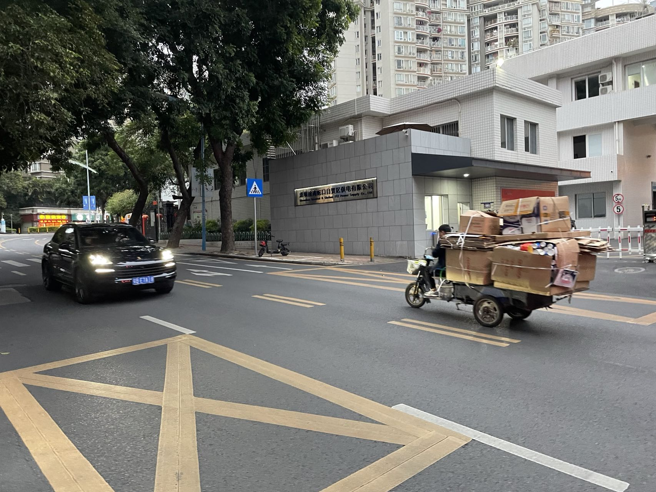
Figure 5.9 – Alternative transportation in Shenzhen

Ideas for Future Research
The finding of this research are valuable as not only indicate that urban mobility has similar solutions (those that we examined were the same) throughout the world, but also that the people in different industries and places have very different priorities when it comes to transportation. As this research was part of a Master’s program there was the element of time limitation involved as it is to be completed within one academic year. Also, a big limitation was that, although I was an active member of the local community, I was still a foreigner with a specific background living in Shenzhen for only four years, therefore I did not have that big of a network.
Ideas for the future would be a local member of the community to try to collect classification tables for mobility issues in the city of Shenzhen That would probably give a bigger sample to the researcher and therefore more valuable results. Also, a comparison of results with a different city would be interesting (the New Zeeland example in Chapter 2 for example). Taking into consideration the Farmaki approach of splitting the stakeholder groups to EU and GR, in this research paper there could be two separate groups, if more participants were available. One of the groups would be foreigners that are residents in Shenzhen and the other group would be Chinese citizens.
Looking to decrease the bias that potentially was present in the answers, the format of questions could be changed. Based on the reactions of some participants, it appears that the way the completion of the classification table was set, it created the idea that they are judging the government. There are ways that the classification could have happen as a result of answering question that were not directly linked with the policies of the government, which would make the responses easier to collect –judging from my experience of the opposite. As a result, a well put set of questions, would give a sample bigger that 30 people, while it would reduce the error introduced by potential bias. Having a sample bigger than 30 participants, would allow the value Phi that was used by PROMETHEE to give us an optimal ranking of the policies.
Another interesting approach would be to choose policies that are unique to the area. China tends to do things differently, either by being all about innovation and progress or by prioritizing traditions over sustainable plans. The policies that were chosen for this particular research were similar to those of a European country, as the main goal was to compare the final ranking between a Mediterranean city to those of a Chinese one. If that was not the main goal of the research, it would be of great interest to see the evaluation and ranking of policies that only apply in the areas of South East Asia, or specific policies for the different Special Economic Zones.
Considering how reputable the MCDA approach is, a different tool could have been used to result to the final ranking. Methods as ELEKTRA or TOPSIS are only a couple of the many different ones available for use. Well established and widely used tools like this and the comparison of the different results, would give a better understanding of how the equations chosen for comparison can affect the final results.
Finally, this research could improve by taking advantage of more function on the PROMETHEE platform. GAIA and Visual Stability Intervals are only a couple of the many functions that could shed more light on how the ranking is affected by the different criteria and how different decisions maker can make an evaluated choice by focusing on a specific aspect of the problem.
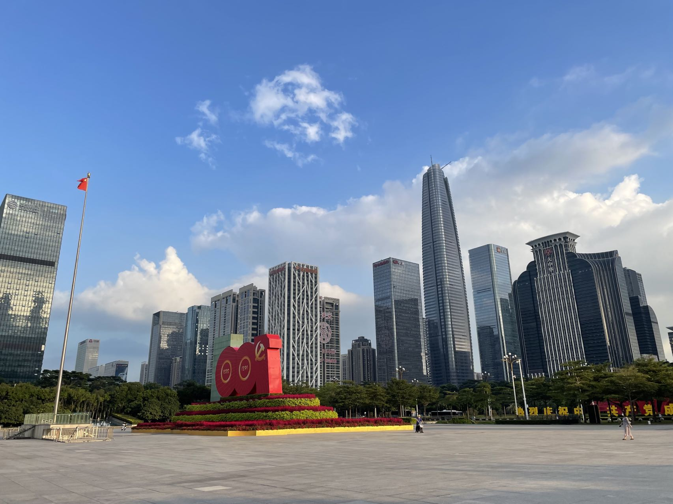
Figure 6.1 – View of the city of Shenzhen

References
- Eurostat, 2020
- Carbon Pollution from Transportation, EPA, 2020
- European Commission, 2020
- Xiaozi Liu, Interactions between economic growth and environmental quality in Shenzhen, China's first special economic zone, 2007
- Min Wu, The special economic zones and innovation: Evidence from China, 2021
- Long Chen, Investigating the spatiotemporal pattern between the built environment and urban vibrancy using big data in Shenzhen, China, p3, 2022
- Yanchong Zheng, A systematic methodology for mid-and-long term electric vehicle charging load forecasting: The case study of Shenzhen, China, 2020
- Eleni Farmaki, Assessing sustainable urban mobility policies in the Mediterranean tourism destinations through multi criteria decision making models, 2018
- Isabel Magalhaes, Evaluating the potential of mobility plans for achieving sustainable urban development, p.2 , 2022
- Eleni Farmaki, Assessing sustainable urban mobility policies in the Mediterranean tourism destinations through multi criteria decision making models, 2018
- Böhler, S., Brand, R., B runner, L., Juliat, M., Rupprecht, s., Somoza, L., Cré, I. Topic Guide: Planning for more resilient and robust urban mobility. POLIS, and Rupprecht Consult - Forschung & Beratung GmbH (Ed). POLIS, Brussels, pp. 10, 2021
- Hüging H., Glensor K, Lah O., Need for a Holistic Assessment of Urban Mobility Measures – Review of Existing Methods and Design of a Simplified Approach. Transportation Research Procedia, 4, 3-13, 2014
- Oubahman, L., & Duleba, S. Review of PROMETHEE method in transportation. Production Engineering Archives, 27.1, 69–74. 2021
- Vidović, K., Šoštarić, M. i Budimir, D. An Overview of Indicators and Indices Used for Urban Mobility Assessment. Promet - Traffic&Transportation, 31.6, 703-714, 2019
- Nalmpantis, D., Roukouni, A., Genitsaris, E. Stamelou A., Naniopoulos A. Evaluation of innovative ideas for Public Transport proposed by citizens using Multi-Criteria Decision Analysis (MCDA). European Transport Research Review, 11.22, 2019
- Kiciński, M., & Solecka, K. Application of MCDA/MCDM methods for an integrated urban public transportation system – case study, city of Cracow. Archives of Transport, 46.2, 71–84, 2018
- Bulckaen, J., Keseru, I., Donovan, C., Davies, H., & Macharis, C. Development of a new evaluation framework for urban and regional mobility projects. In Benelux Interuniversity Association of Transport Researchers: Transportation Research Days, 2015
- Sun, H., Zhang, Y., Wang, Y., Li, L., & Sheng, Y. A social stakeholder support assessment of low-carbon transport policy based on multi-actor multi-criteria analysis: The case of Tianjin. Transport Policy, 41, 103-116, 2015
- Morfoulaki, M.; Papathanasiou, J. Use of the Sustainable Mobility Efficiency Index (SMEI) for Enhancing the Sustainable Urban Mobility in Greek Cities. Sustainability, 13, 1709, 2021
- Jana Majchráková, Transportation Cost as an Important Element of a Supplier Selection Process Based on a Multi-Criteria Decision Analysis, 2021
- Monsak Socharoentum, Multi-modal transportation with multi-criteria walking: Personalized route recommender, p44-54, 2016
- Samet Güner, Quality of public transportation based on the multi-criteria approach and from the perspective of user's satisfaction level: A case study in a Brazilian city, Júlia Barros dos Santos, p.1233-1244, 2021
- Chengjiang Li, Michael Negnevitsky, Xiaolin Wang, Wen Long Yue, Xin Zou,Multi-criteria analysis of policies for implementing clean energy vehicles in China,Energy Policy,Volume 129, Pages 826-840, 2019
- Fei Ye, Yingying Chen, Lixu Li, Yina Li, Ying Yin,Multi-criteria decision-making models for smart city ranking: Evidence from the Pearl River Delta region, hina,Cities,Volume 128, 2022
- Muhammad Bilal, A multifaceted evaluation of hybrid energy policies: The case of sustainable alternatives in special Economic Zones of the China Pakistan Economic Corridor (CPEC), Sustainable Energy Technologies and Assessments, Volume 52, Part A, 2022
- M.A. Hasan, R. Chapman, D.J. Frame, Acceptability of transport emissions reduction policies: A multi-criteria analysis, Renewable and Sustainable Energy Reviews, Volume 133, 2020
- S. Griffiths, D. Furszyfer Del Rio, B. Sovacool, Policy mixes to achieve sustainable mobility after the COVID-19 crisis, Renewable and Sustainable Energy Reviews, Volume 143, 2021
- Srijita Nundy, Aritra Ghosh, Abdelhakim Mesloub, Ghazy Abdullah Albaqawy, Mohammed Mashary Alnaim, Impact of COVID-19 pandemic on socio-economic, energy-environment and transport sector globally and sustainable development goal (SDG), Journal of Cleaner Production, Volume 312, 2021
- Subodh Chandra Pal, Indrajit Chowdhuri, Asish Saha, Manoranjan Ghosh, Paramita Roy, Biswajit Das, Rabin Chakrabortty, Manisa Shit, COVID-19 strict lockdown impact on urban air quality and atmospheric temperature in four megacities of India, Geoscience Frontiers, 2022
- Dimitra Tarasi, Tryfon Daras, Stavroula Tournaki, Theocharis Tsoutsos, Transportation in the Mediterranean during the COVID-19 pandemic era, Global Transitions, Volume 3, 2021
- Vijaya Kumar Manupati, M. Ramkumar, Vinit Baba, Aayush Agarwal, Selection of the best healthcare waste disposal techniques during and post COVID-19 pandemic era, Journal of Cleaner Production, Volume 281, 2021
- Majid Behzadian, R.B. Kazemzadeh, A. Albadvi, M. Aghdasi, PROMETHEE: A comprehensive literature review on methodologies and applications, European Journal of Operational Research, Volume 200, Issue 1, 2010
- Wei-xiang Li, Bang-yi Li,An extension of the Promethee II method based on generalized fuzzy numbers, Expert Systems with Applications, Pages 5314-5319, 2010
- C. Macharis, J. Springael, K. De Brucker, and A. Verbeke, “PROMETHEE and AHP : The design of operational synergies in multicriteria analysis . Strengthening PROMETHEE with ideas of AHP” vol. 153, pp. 307–317, 2004
- J.-P. Brans and B. Mareschal, Promethee Methods. In: Multiple Criteria Decision Analysis: State of the Art Surveys. International Series in Operations Research & Management Science, no. 78. Springer, New York, NY, 2005.

